NAME: ……………………………………………. INDEX NO: …………………CLASS....….

ADM. NO. ………… SIGNATURE: ………………………… DATE: ……………………

232/3
PHYSICS
PAPER 3
(PRACTICAL)
SEPTEMBER
TIME: 2 ½ hours
KASSU JOINT EXAMINATION TEST
Kenya Certificate of Secondary Education (KCSE)
PHYSICS
PAPER 3
TIME: 2 ½ HOURS

INSTRUCTIONS TO CANDIDATES
- Write your Name, Index Number and Admission number in the spaces provided above.
- Sign and write the date of Examination in the spaces provided above.
- Answer all questions in the spaces provided.
- You are supposed to spend the first 15 minutes of the 2½ hours allowed for this paper reading the whole paper carefully before commencing your work.
- Marks will be given for clear records of observations actually made, their suitability, accuracy and the use made of them.
- Candidates are advised to record their observations as soon as they are made.
- All working must be clearly shown where necessary.
- Mathematical tables and silent electronic calculators may be used.
- This paper consists of 8 printed pages. Candidates are advised to check that all pages are printed as indicated and no questions are missing.

FOR EXAMINER’S USE ONLY
Question 1 | TOTAL
Max. Score | 20
Candidate’s Score
Question 2 | TOTAL
Max. Score | 20
Candidate’s Score

GRAND TOTAL

QUESTION ONE
This question has two parts A and B. Answer all the parts

PART A
You are provided with the following:
- A metre rule
- Two identical 100g masses (labelled A and B)
- Liquid L in 250ml beaker,$\frac{3}{4}$ full.
- Three pieces of thread, each 30cm long.
- Stand with clamps
- Tissue paper.
- Vernier calipers
Proceed as follows:
- Take one 100g mass and measure the diameter d and height h using the Vernier calipers
d=………………………………..m
h=………………………………..m (1mark)
- Determine the volume V given that $V=π(\frac{d}{2})$²h
V…………………………………………m³ (1mark)
- Using a stand and one piece of thread, suspend the metre rule in air such that it balances horizontally. Record the position of the centre of gravity. G.

G = ___________________________________________ cm (1mark)
NOTE: The metre rule should remain suspended at this point throughout the experiment.
- Set up the apparatus as shown in Figure 1 below;
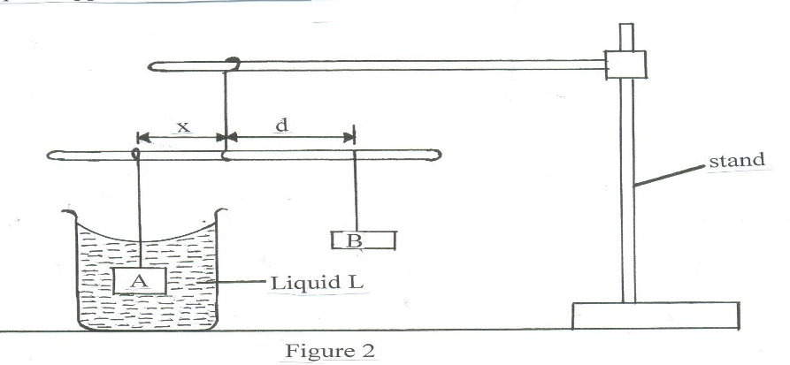
- Suspend the mass A at a distance x = 30cm and completely immerse it in liquid L without touching the sides of the beaker.
- Hang mass B and adjust its position such that the rule is balanced and measure the distance d cm. Tabulate your results in table 1 below;

$$x (cm)$$ | $$30$$ | $$35$$ | $$40$$
$$d (cm)$$
$$\frac{d}{x}$$
(2marks)

- Determine the weight F of one of the masses A or B in air. Given that
$g=10N/Kg$ and A =B
Weight F in air =…………………………………… (1mark)
- Using the principle of moments, determine the apparent weight P of A when completely immersed in liquid L.

Apparent weight P = …………………….. (2marks)
- Find the upthrust U on A when completely immersed. (1marks)

Upthrust; U =……………….

- Determine the density of liquid L, given that; (1mark)
$ρ=\frac{Un}{V}$ where $n=0.1Kg/N$

PART B
You are provided with the following apparatus:
- Resistance wire fitted on a millimeter scale labeled MN
- Switch
- Voltmeter
- Ammeter
- Two dry cells in a cell holder
- Six connecting wires
- Micrometer screw gauge
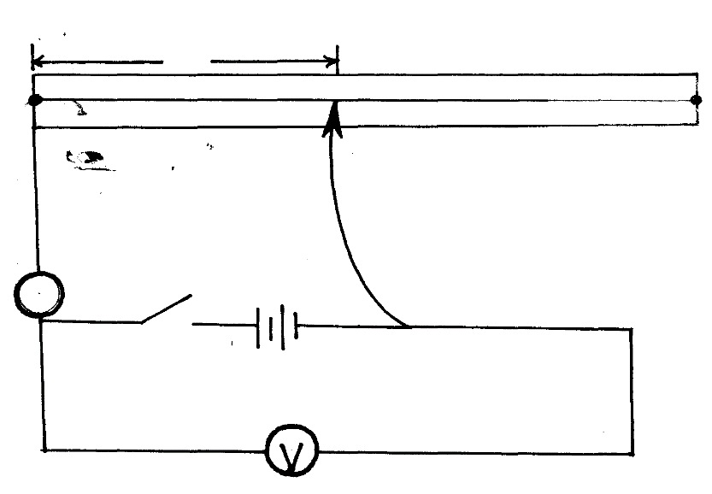
- Set –up the apparatus as shown in the Figure 2 below;
l
M
N
Jockey
A
Switch

- Remove the crocodile clip from the resistance wire MN and close the switch. Record the voltmeter reading V₀.
V₀ = …………………………………. (1mark)
- Attach the Jockey to the resistance wire such that l = 50cm
- Record the voltmeter and ammeter readings as V₁ and Z respectively
V₁ =…………………………………....... (1mark)
Z =……………………………………… (1mark)
- Determine the value of X given that $X= \frac{V1}{Z}$ (1mark)

- Use the equation below to determine the value of k , where m = 2.549Ω (2marks)

$\frac{V_{1}}{V_{0}-V_{1}}$ = $\frac{mX}{5}$ + k

- Measure the diameter d of the of the wire on the millimeter scale using the micrometer screw gauge

d = …………………………mm =……………………………….m (2marks)

- Determine the resistivity ꝭ of the wire used in this experiment given that (2marks)
$X=\frac{ꝭl}{A}$

QUESTION TWO
You are provided with the following apparatus
- A glass prism
- A plain sheet of paper
- A soft board
- 4 optical pins
- 4 paper pins
Proceed as follows

- Firmly fix the plain sheet of paper on the soft board using the thumb pins and place the prism near the centre of the paper. Trace the outline of the prism using a pencil.
- Remove the prism from the outline and label the vertices of the outline AB and C as shown in Fig. 3a

M
Ɩ

L N

Measure Angle LMN and length Ɩ
Angle LMN…………………………… (1mark)
Length Ɩ ………………………………… (1mark)

- On the side ML mark a point and draw a normal. Measure an angle T of 60° from the surface and draw a line along this angle as show in Figure 3b.
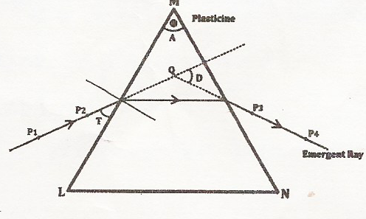
- Replace the prism on the outline and fix pins P₁ and P₂ on the 60° line at a distance of 3cm from each other. View the images of the pins P₁ and P₂ through side MN and fix P₃ and P₄ so that all the pins appear on one line.
- Remove the prism and draw a line to pass through the holes made by pins P₃ and P₄.extend the line into the outline as shown in figure 3b.Also extend the 60° line so that the two lines cross each other. Determine angle D and record it in the table below
- Repeat the procedure and complete the table below (6marks)
$$Angle T (°)$$ | $$60°$$ | $$50°$$ | $$40°$$ | $$30°$$ | $$20°$$
$$Angle D(°)$$
$$Angle I°(90°-T)$$

- Determine the average value D_{m} of D (1mark)

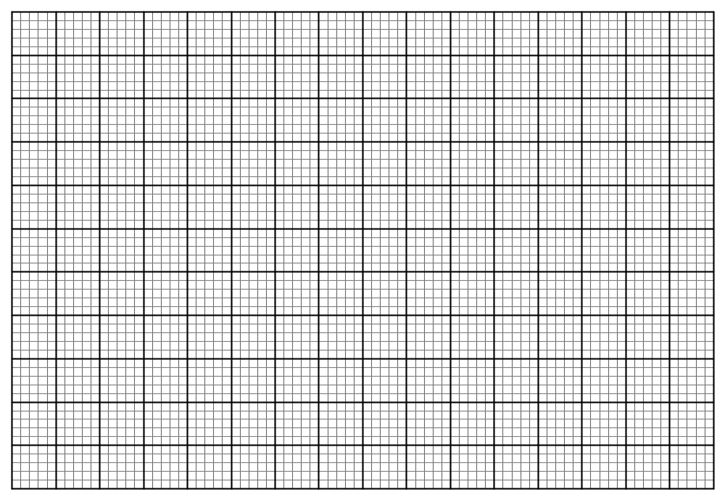
- On the grid provided plot a graph of Angle D (y-axis) against Angle I (5marks)
- Use your graph to determine the lowest value H_{min} of angle D
H_{min}…………………………………. (1mark)
- Determine the value of I° when D° is 41° (2mark)
…………………………………………………………………………………………………
- Determine the constant K for the glass prism from the formula (3marks)
