Name………………………………………………………………………Index NO…...............................................
232/3 Candidate`s Signature……………………………
PHYSICS Date……………………………………………………….
(PRACTICAL)
Paper 3 Term 2 Year 2024
2 $\frac{1}{2}$ hours
Kenya Certificate of Secondary Education (KCSE)
Instructions to candidates
- Write your name and index number in the spaces provided above.
- Sign and write the date of examination in the spaces provided above.
- Answer all the questions in the spaces provided in the question paper.
- You are supposed to spent the first 15 minutes of the 2 $\frac{1}{2}$ hours allowed for this paper reading the whole paper carefully before commencing your work.
- Marks are given for a clear record of the observations actually made, their suitability, accuracy and the use made of them.
- Candidates are advised to record their observations as soon as they are made
- Non-progmmable silent electronics calculators may be used.
- This paper consists of 9 printed pages.
- Candidates should check the question paper to ascertain that all the pages are printed as indicated and that no questions are missing.
- Candidates should answer the questions in English.
For Examiner`s Use Only
Question 1 | a | b | d | e | f(i) | f(ii) | g | Total
Maximum Score | 1 | 1 | 5 | 5 | 3 | 3 | 2 | Total
Candidate`s Score |  |  |  |  |  |  |  | Total

QUESTION 2 | a | b | d | e | f(i) | f(ii) | i | j | k(i) | k(ii) | k(iii) | Total
Maximum Score | 2 | 2 | 1 | 2 | 1 | 3 | 4 | 1 | 1 | 1 | 2 | Total
Candidate`s Score |  |  |  |  |  |  |  |  |  |  |  | Total

GRAND TOTAL
QUESTION ONE
- You are provided with the following:
- An ammeter
- A voltmeter
- Two cells (size D)
- A cell holder
- A switch
- A wire labelled L mounted on a millimeter scale
- A micrometer screw gauge (to be shared)
- Six connecting wires at least four with crocodile clips
Proceed as follows:
- Using a micrometer screw gauge, measure and record the diameter d of the wire L.
(1 mark)
d = ……………………………………….mm

d = ……………………………………….m

- Place the two cells in series in the cell holder and use the voltmeter to measure the total electromotive force (emf) E₀ of the battery. (1 mark)

E₀ = ………………………………………V

- Starting with the switch open, connect the circuit as shown in figure 1 below. P and Q are points on the wire L such that PQ is 60 cm. (PQ should remain 60 cm throughout the experiment)
N is a point on the wire such that PN is 10cm (0.1 m)
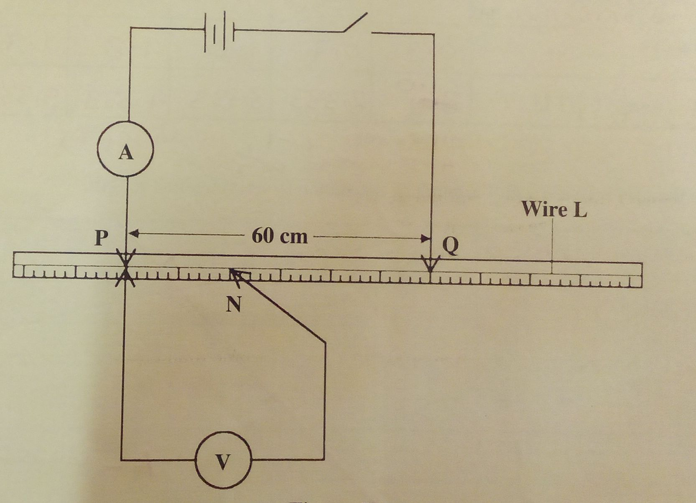
Figure 1
- (i) Close the switch and record the current I. (1 mark)

I = …………………………………A.

(ii) Measure and record in table 1 the potential differences across PN.

(iii) Measure and record the potential difference across PN for the other values of PN shown in table 1 and complete the table. (The current is expected to remain constant)
Hint: The switch should be crossed only when reading the voltmeter.

Table 1 (4 marks)
Length PN (m) | 0.1 | 0.2 | 0.3 | 0.4 | 0.5 | 0.6
p.d (V)

Resistance ($\frac{v}{1})Ω$

- On the grid provided, plot a graph of resistance (y-axis) against length.
(5 mark)

- From the graph, determine:

(i)the slope S and its units. (3 marks)

…………………………………………………………………………………………………………………………………
…………………………………………………………………………………………….……………………………………

………………………………………………………………………….………………………………………………………

……………………………………………………….…………………………………………………………………………

…………………………………….…………………………………………………………………………………….........

(ii) the constant K and its units given that
$s=\frac{4k}{πd^{2}}$ (3 marks)
………………………………………………………………………………………………………………..…………………

……………………………………………………………………………………………..……………………………………

…………………………………………………………………………..………………………………………………………

………………………………………………………..…………………………………………………………………………

…………………………………..……………………………………………………………………………………………...

- Determine constant t given that

$t=\frac{E_{0}-v_{n}}{I}$

Where Vn is the p.d at PN = 0.6 m. (2 marks)

……………………………………………………………………………………………………………….…………………

…………………………………………………………………………………………….……………………………………

………………………………………………………………………….………………………………………………………

…………………………………………………………………………………………………………………………………..
QUESTION TWO

- You are provided with the following:
- Triangular glass prism
- Four optical pins
- Some sellotape
- A soft board
- A plain sheet of paper

Proceed as follows:
PART A
- Fix the plain sheet of paper on the soft board using some sellotape. Place the triangular prism on the paper and trace its outline on the sheet of paper. Remove the prism and use a ruler to extend the three sides of the outline. See Figure2.

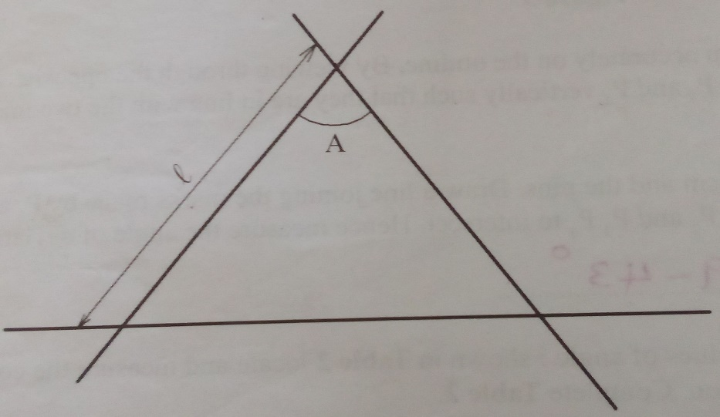
Figure 2
Measure angle A and the length $l$.

A = …………………………………………………………. (1 mark)

$l$ = ………………………………………………………….cm (1 mark)

NB: The plain sheet of paper must be submitted together with the question paper.

- At a point about a thirdway along one side of the outline from angle A, draw a normal. (2 marks)

- Draw a line at angle i = 40° to the normal. Stick two pins P₁ and P₂ vertically on this line. (see Figure 3)

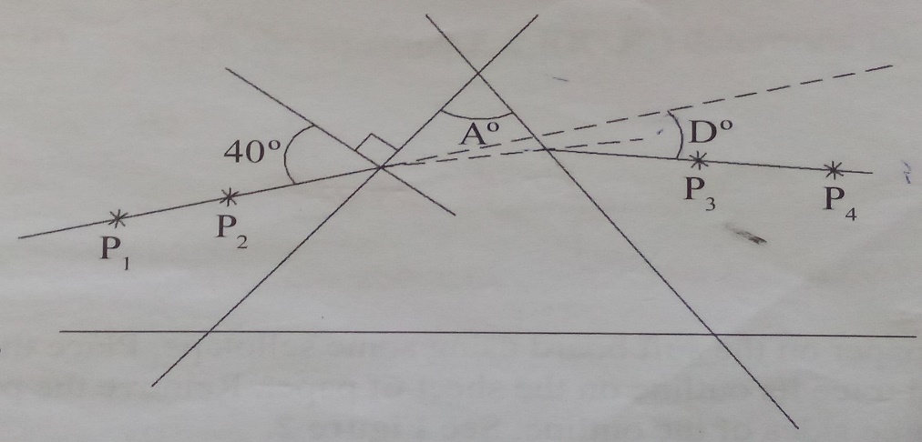
Figure 3

Place the prism accurately on the outline. By viewing through the opposite side, stick the two pins P₃ and P₄ vertically such that they are in line with the two images of pins P₁ and P₂.

- Remove the prism and the pins. Draw a line joining the marks made by P₃ and P₄. Extend lines P₁ P₂ and P ₃ P₄ to intersect. Hence measure the angle of deviation D.

D = ……………………………………………. (1 mark)

- For two other values of the angle i shown in Table 2 locate and measure the corresponding angles of deviation. Complete Table 2.

Table 2 (2 marks)

i | 40° | 50° | 60°
D

- (i) Determine the average value D_{m} of D. (1 mark)
………………………………………………………………………………………………………………………………….

………………………………………………………………………………………………………………………………….

…………………………………………………………………………………………………………………………………..

(ii) Determine the constant K using the equation;

$k=\frac{\sin\left(\frac{A+D_{m}}{2}\right)}{\sin{\frac{A}{2}}}$ (3 marks)
........................................................................................................................................

........................................................................................................................................

........................................................................................................................................

PART B
You are provided with the following:
- 100 ml beaker
- A meter rule
- Source of light
- A screen

Proceed as follows:
- Place the 100 ml beaker on a meter rule and pour 80 cm³ of water into it. Arrange a lamp (source of light) and a screen on either side of the beaker. (see figure 4)
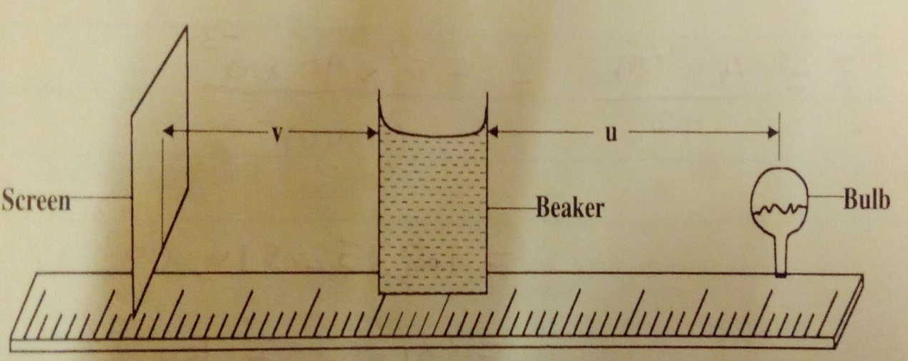
Figure 4

- Adjust the position of the lamp on the metre rule so that its centre is a distance u = 12 cm from the beaker. Switch on the light. Adjust the position of the screen until a well focused vertical line (the image of filament) is formed on the screen. Measure and record in table 3 the image distance V between the screen and the beaker.

- Repeat part (b) for the values of u shown in table 3 and complete the table.

Table 3 (4 marks)

Distance u (cm) | 12 | 16 | 20
Distance V (cm)
$$y=\frac{Uv}{U+v}$$

- Determine m, the mean value of y using the values in table 3. (1 mark)

m = ……………………………………….

- (i) With the meter rule outside the beaker, measure the height h of the water meniscus above the bench. (1 mark)

h = …………………………………………cm

(ii) Determine the value of P given that (1 mark)
$P=\frac{5}{\sqrt{h}}$
…………………………………………………………………………………………………………………………………..

…………………………………………………………………………………………………………………………………..

(iii) Hence determine the value of f given that $f=\frac{P}{2m}+1$ to one decimal place.
(2 marks)
…………………………………………………………………………………………………………………………………

…………………………………………………………………………………………………………………………………

…………………………………………………………………………………………………………………………………

…………………………………………………………………………………………………………………………………..
THIS IS THE LAST PRINTED PAGE.
K.C.S.E 232/3 TERM II 2024.

