Name:…………………………………………………………Index no:…………………………
Sign:………………………………..
Date:……………………………….

312/2
GEOGRAPHY
PAPER 2

TIME: 2 ¾ HOURS

SET 10
FORM 4

312/2
GEOGRAPHY
PAPER 2

INSTRUCTIONS TO CANDIDATES:
- This paper consists of two sections A and B.
- Answer all questions in section A
- In section B answer question 6 and any other TWO questions
- All answers must be written in the answer booklet provided

This paper consists of 4 printed pages.
Candidates should check the question paper to ensure that all
pages are printed as indicated and no questions are missing.
GEOGRAPHY PAPER 2

SECTION A: ANSWER ALL QUESTIONS
1. a) Name two types of dairy cattle in Denmark. (2mks)
b) Give two characteristics of dairy farming in Denmark. (2mks)

2. (a) Differentiate between horticulture and market gardening. (2mks)
(b) Mention three factors that have supported the horticultural industry in Kenya. (3mks)

3. a) Name two minerals mined using alluvial method. (2mks)
b) Explain two negative effects of mining on the environment. (4mks)

4. (a) Apart from drought name other three environmental hazards experienced In Kenya. (3mks)
(b) State two causes of the flooding. (2mks)

5. (a) Distinguish between population distribution and population density. (2mks)
(b) State any three problems associated with high population growth rate in Kenya. (3mks)

SECTION TWO: ANSWER QUESTION 6 AND ANY OTHER TWO QUESTIONS FROM THIS SECTION

6. The table below shows the various modes of transport used by tourists visiting Kenya between
the years 2006 and 2009. Use it to answer the following questions.
Mode of transport | No. of tourists.
Road | 2006 | 2007 | 2008 | 2009
Road | 100,000 | 50,000 | 150,000 | 200,000
Air | 600,000 | 650,000 | 700,000 | 800,000
Water | 200,000 | 150,000 | 100,000 | 50,000
Source: Hypothetical data.
- i) Suggest one reason why water transport experienced a steady decline over
the period. (2mks)
ii) Calculate the percentage increase in the number of tourists between the years 2008
and 2009. (3mks)

iii) Draw a compound bar graph to represent the data. (9mks)

b) i) Explain any three roles played by transport in the economy of Kenya. (6mks)

ii) Name one highway created in Africa to ease transport across the continent. (1mk)

c) Form four students from Buchenya secondary school visited Kisumu Airport for a field
study.

i) Identify two methods they used to record their data. (2mks)
ii) Give two follow up activities they engaged in. (2mks)

7. (a) Differentiate between domestic and international tourism. (2mks)
(b) Name three tourist attractions in each of the following areas in Kenya.
(i) the coast (3mks)
(ii) inland (3mks)
(c) (i) State four reasons why Switzerland gets more tourists than Kenya.
(ii) Explain three problems associated with tourism in Kenya. (6mks)
(d) A group of students carried out a field study in a game park.
(i) State two advantages of using questionnaire as a method they used in collecting
data. (2mks)
(ii) State five ways in which they prepared for the study. (5mks)
8. (a) (i) Define settlement. (2mks)
(ii) Apart from the dispersed settlement, name two other types of settlements. (2mks)
(b) Explain three factors that may lead to dispersed settlement in an area. (6mks)
(c) Define the following terms;
(i) Urbanization (1mk)
(ii) Entreport (1mk)
(iii) Explain three problems Mombasa experiences as it grows. (6mks)
(d) You have been asked by your geography teacher to undertake a field study in the port
town of Mombasa.
(i) State two objectives of your study. (2mks)
(ii) State five functions of Mombasa as a port city you are likely to find out. (5mks)
9. (a) (i) Define the term trade. (1mk)

(ii) Name two levels of external trade. (2mks)

(b) (i) Differentiate between invisible exports and visible exports. (2mks)

(ii) Name two leading export commodities from Kenya. (2mks)

(c) Explain four measures Kenya may take to reduce the unfavourable balance of
trade. (8mks)

(d) (i) Name two regional trade blocks in Africa. (2mks)

(ii) Explain four benefits of international trade to Kenya. (8mks)

10. a) Give four methods used by the government of Kenya to decentralize industries (4mks)
b) Explain four factors that make the development of “Jua Kali” industry most
suitable to the government of Kenya (8mks)
c) Explain four factors that have slowed down industrialization in Kenya (8mks)
d) State five factors that have made Japan a major car producer in the world (5mks)

GEOGRAPHY PAPER 2
MARKING SCHEME
1. a)
- Fresian
- Ayrshire
- Guernsey 1x2=2mks
b)
- Cattle kept indoors in winter and autumn.
- Cattle are fed on fodder.
- Dairy farming spread all over the country.
- Dairy products produced mainly for export.
- Dairy farming is highly mechanized.
- Dairy farming is highly specialized.
- Dairy cooperatives are well developed.
- Artificial Insemination (A.I) Services are widely used. 1x2=2mks
2.
- Horticulture is the growing of vegetables fruits and flowers on large scale for sale while Market gardening does not involve growing of flowers but the cultivation of vegetables and fruits for local consumption 2mks
- Climatic condition
- Fertile soils
- Availability of ready market
- Improved infrastructure
- Support from the government through the horticultural development authority (HDA)
- Availability of extension services
- Availability of loan facilities.
3. a) - Gold
- Tin
- Platinum (1×2 = 2mks)
b) - Open pits left after mining makes the land ugly/ an eye sore
- Fumes/ dust from the mines can be poisonous to living organism may hinder. (4mks)
c) Reasons why there is little railway linkage amongst African countries.
- Have inadequate capital to finance construction
- Railways gauges are different hence cannot be connected to one another
- There is little trade among some states. ( any 2 x 1 =
4.a)-lightning
-hailstones
Dust storms
Pests and diseases
Strong winds
Famine 3x1=3mks
(b)causes of flooding
-low lying land – rain water spreads easily
-torrential rainfall – rivers overflow
-wide flood plains – water spread over wide areas
-Siltation of rivers – they become shallow leading to spilling
-non – porous soil – water flows and spreads over the surface
- heavy rainfall – water level in lakes rise and floods in the surrounding lowlands 2x1 = 2mks
5. a) Population distribution and population density.
- Population distribution is the way people are spread out on the land whereas population density is the number of people unit area of land.
b) Problems associated with high population growth rate in Kenya. (3mks)
- A high rate of unemployment.
- High crime rate as people seek ways of supporting themselves.
- High demand for social amentities.
- The dependency ratio decreases.
- High demand for food sometimes leading to food shortages.
- Strain on natural resources and scarcity of land.
6.a) i) Increased piracy off the East African Coast. 1x2=2mks
ii) Calculate the percentage increase in the number of tourists between the years 2008 and 2009.
1,050,000 – 950,000 = 100,000✔
100,000 x 100
950,000
✔
= 10.526%/10.53%/10.5%
iii) Draw a compound bar graph to represent the data. 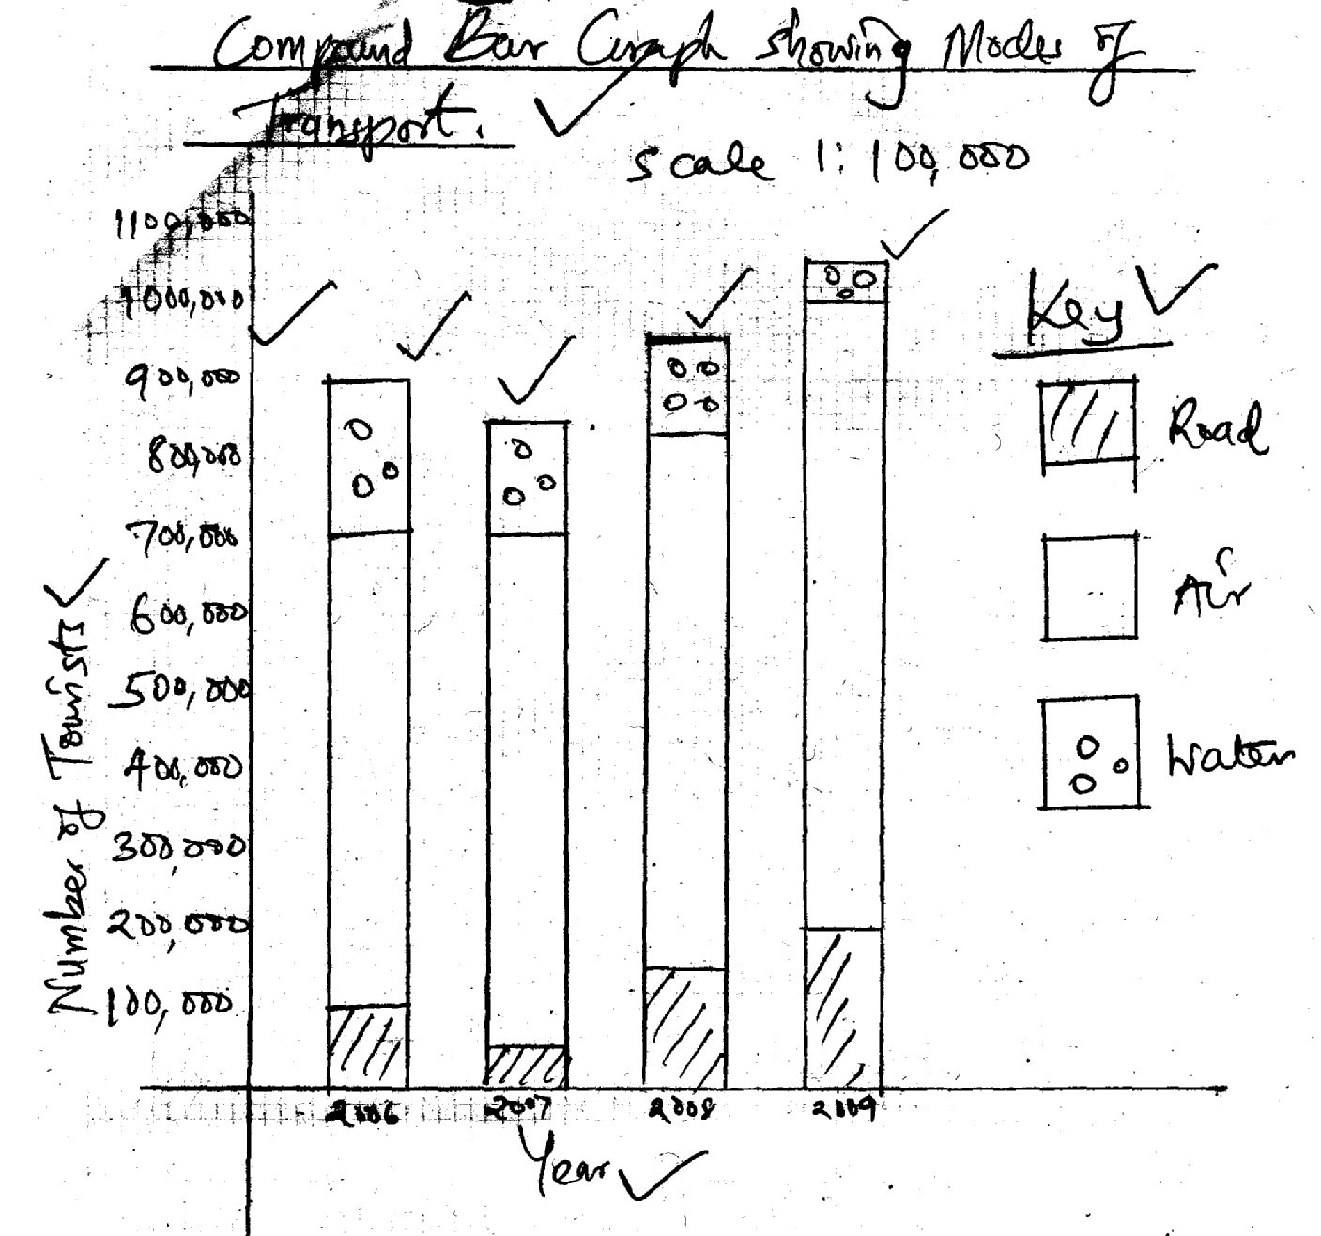
b) i) Explain any three roles played by transport in the economy of Kenya.
- Influences the movement of raw material/finished products affecting location/distribution of economic activities/exploitation of resources.
- Makes movement of goods/services possible hence expanding the market.
- Creates employment opportunities reducing unemployment/improving the living standards.
- Enables the movement of tourists to/in exchange used to import goods into the country.
- Earns revenue to the government through taxation which is used to develop the country/put up facilities/ other sectors of economy.
- Leads to urbanization. 3x2 6mks

ii) Name one highway created in Africa to ease transport across the
continent.
- Great North road (Gaberon – Cairo)
- Trans Africa Tripoli – l
- Tripoli - Lagos
- Dakar – Ndjamena
- Lagos – Nouakchott 1x1=1mk
c) Form four students from Buchenya secondary school visited Kisumu Airport for a field study.
i) Identify two methods they used to record their data.
- Note taking
- Video recording
- Filling questionnaires
- Taking photographs.
- Tallying
- Sketching. 2x1=2mks

ii) Give two follow up activities they engaged in.
- Compile notes
- Discuss findings.
- Draw better diagrams/maps
- Display photographs.
- Making models. 2x1=2mks
7. a) Differentiate between domestic and international tourism.
Domestic tourism refers to visits within a country by residents of that country whereas international tourism refers to the movement of persons from one country to another for pleasure.

b) Name three tourist attractions in each of the following areas in Kenay.
i) The coast.
- Beaches along the coast.
- Museums i.e fort Jesus.
- Gedi ruins.
- Vasco da Gama pillar.
- Mangrove swamps.
- Marine life.
- The Haller’s Park (3x1 = 3mks)

ii) Inland.
- National parks, game reserves and sanctuaries.
- Landscapes of various shapes.
- Historical and pre-historic sites.
- Varied cultures.
- Hot springs, geysers and fumaroles.

c)
- Switzerland is easily accessible to tourist from Europe while Kenya is far away.
- Tourist from Europe proper to visit sites nearer home.
- Peaceful atmosphere in Switzerland encourages tourists, to visit whole Kenya experiences some level of insecurity.
- Switzerland has efficient marketing systems than Kenya.
- Switzerland has well developed transport network than Kenya.
- In Switzerland hotel industry is advanced than Kenya.

8. (a) i) Is a place with houses where people live.
ii)
- Nucleated/clustered settlements.
- Linear settlement.
- Radial settlement. (1x2 = 2mks)
b)
- Presence of pests/diseases which discourage settlements.
- Infertile soils which attract few people.
- Mts/forested areas which attract few settlements.
- Harsh climate/extreme weather conditions which may attract few people.

c) Define the following terms.
i) Urbanization:
This is a process by which a population is transformed from rural type to an urban one. (1mk)

ii) Entreport:
Is a centre, usually a port, where goods in transit can be stored while waiting re-exportation.
iii) Explain three problems Mombasa experiences as it grows.
- Limited space for expansion of the Island which has resulted into expansion of the town towards the mainland.
- Inadequate housing facilities which has led to growth of slums/informal settlements.
- Congestion and traffic jams on roads due to narrow streets.
- Unemployment resulting to increased crime/socialills.
- Pressure on available social amenities due to growing population.

d) You have been asked by your geography teacher to undertake a field study in port town of Mombasa.
i) State two objective of your study.
- To find out the boundary of the town.
- To find out how the town is administratively divided.
- To find out the future plans for the town. (any other relevant)

ii) State five functions of Mombasa you are likely to study.
- It’s a loading and unloading centre.
- It is a commercial centre.
- It’s a clearing and forwarding centre.
- It is a industrial centre.
- It’s a tourist centre.
- It’s a cultural centre.
- It’s an administrative centre for coast province.
- It offers transport/and communication services.
- Storing and protection of goods.
- It is a residential centre.

9. (a)
- Buying and selling of goods and services

- Regional trade
- International trade

(b) (i) Differentiation between invisible exports or visible exports.
- Visible exports are tangible goods sold by a country while invisible exports are intangible goods or services sold by a country to another 2mks

(ii) Horticulture, tea
- -Establishing and protecting import substitution industries in order to reduce
importation.
- Encourage the production of high quality manufactured and manufacture good for export in order to fetch higher prices/income
- Diversify the agricultural export base to enable the country have a variety of exports
- Restricting alternative sources of energy in order to reduce importation of petroleum
- Encourage local assembling of machinery since importation of parts is cheaper
- Popularize tourism to increase earnings from invisible exports.

(d) (i)
- East African community
- Common market for Eastern and Southern Africa
- Southern African Development community
- Economic community of west African states

(ii)
- Kenya earns foreign exchange which enables her to import goods from other countries
- The imported industrial inputs have led to growth of manufacturing industries in the country
- It has led to the expansion of industries due to demand for Kenya’s export
- Taxation of commodities and services has generated revenue for the country which is used to develop other sectors of the economy
- Has created employment opportunities in manufacturing and services industry hence improving the peoples living of standards
- Trade has enhanced cooperation between Kenya and other trading partners
- Kenya’s can enjoy a variety of goods due to importations
- Trade has enhanced the exchange of technology between Kenya and the trading partners
- Encourages specialization which leads to production of high quality goods
- Kenya gets ready market leading to income which is used to develop other sectors of the economy. Any 4 x 2 = 8mks

10. a) - Making rural areas more accessible
- Making power readily and cheaply available
- Providing steady water supply in all areas
- Encouraging investors to site their industries in rural areas
- Making land cost affordable (4 x 1= 4mks)
b) - Create employment opportunities to thousands of people who would otherwise be jobless
- Jua Kali products save the country foreign exchange as they reduce some of the imports
- Use materials that would otherwise be thrown away to make valuable items
- Earns the country a substantial amount of foreign exchange
- Produces cheaper goods than those produced in formal industries
- Encourages the appropriate industry in an economy where the population cannot afford high quality goods ( 4 x 2 = 8mks)
c) - Limited capital resources which have forced the country to borrow abroad. Such borrowed loan attract high interest are conditioned leading to few industries
- High competition of our industrial goods to those produced from other countries on international markets / local markets e.g importation of second hand clothes has led to
closure of textile industries in Kenya
- The high cost of energy increase the expenses of industrial process. Investors would prefer other alternatives than operating industries.
- The infrastructures in Kenya are not well developed eg. Road/ rail network is limited to certain areas.
- A few industries have closed down due to poor management and this is because of shortage of skilled labour (4 x 2 = 8mks)
d) - Availability of capital which enables Japan to import raw materials
- Availability of skilled manpower
- The rugged terrain of Japan does not favour the development of agriculture
- Strategic location of Japan enables import raw materials and export its products to all parts of the world
- The Japanese use advanced skills in the production of electronics
- Japan abandoned its aggressive military policies and resorted to industrial development (5 x 1 = 5mks)

