GEOGRAPHY
MARKING SCHEME
PAPER 1
SECTION A
- a) Forces that shape the surface of the earth centripetal – pulls the poles towards each other and causes flattening
- Centrifugal flinging force that causes the bulge at the equator
- Gravitational – pulls towards the centre causing the rounding effect
2 x 1 = 2 marks
b) Characteristics of the crust
- Average thickness 16 – 24km (Mts upto 70/80 km)
- Made up of two parts. the outer and inner crust
- The outer crust made of Silica and aluminium (SIAL)
- The inner crust made of SIMA
- SIAL density - 2.7 gms / cc
- SIMA average density 2.3 - 3.0 gm/cc
- Sial mainly forms the continental crust while Sima forms the oceanic crust.
Max. 3 x 1 = 3 marks
2. Exfoliation dome
- forms in areas with high temps and in homogeneous rocks
- during the day the rocks surface heat up
- this causes the surface layers to expand
- at night low temps result in cooling and contraction of the out layers
- the alternative expansion and contraction results in peeling off from the rock
- this leaves behind a round-off mass known as Exfoliation dome
(5 marks)

- a) A coast us shore
- A coast is a strip of land that is bordering the sea while a shore is the point along the coast that lies between the lowest water tide and the highest point reached by waves.
(2mks)

b) Conditions necessary for the formation of a spit
- relatively shallow and sheltered water
- Availability of a lot of load
- A long one ward shore drift must occur
- A gently sloping shoreline
- A change in the angle of the coastline for deposition to occur
Max 3 x 1 = 3 marks
4.a) Ideal conditions for an artesian well
- the aquifer must outcrop in a region which is a source of water
- the aquifer must did from a region of water intake to form a broad syncline
- the aquifer must lie between impermeable rocks so as to retain water
- the mouth of the well must be lower than the intake area to ensure water comes out on its own. ( max 3 x 1 = 3 marks)
b) Water may reach the surface through
- through spring / wells / seepage
- through capillary action / trangiration (2 marks )
5.a) P. Heath and Moorland Q Bamboo forest
b) Characteristics of Savanna vegetation
- Consists of a grass and scattered trees
- Wetter areas grass is tall and close together
- Drier areas, the grass is shorter and
- Grass dominates the vegetation
- The trees are shorter and more scattered
- The trees are umbrella shaped
- Some trees like baobao have thick back
SECTION B
Answer question 6 and any other 2 questions from this section
6.a. i)Six figure grid ref. for Teldet school. (2mks)
406595√√
ii) Approx. area of Homa Bay District (2mks)

Full sq = 1
Half sq = 10/2 = 5
A = 5x1 = 6 km²√ √ + 0.5 ( 5.5 – 6.5)
b i) Direction and bearing of Mindililwet school from Chebribi junction (2mks)
NE√ 049º√
iii) Measure the distance of river Sondo from Northing 50 to the End in the West.
11.8 km√√ ± 0.1 ( 11.7 – 11.9 km )
c) Draw a rectangle representing the area West of Easting 30 and North of Northing 50. (2mks)
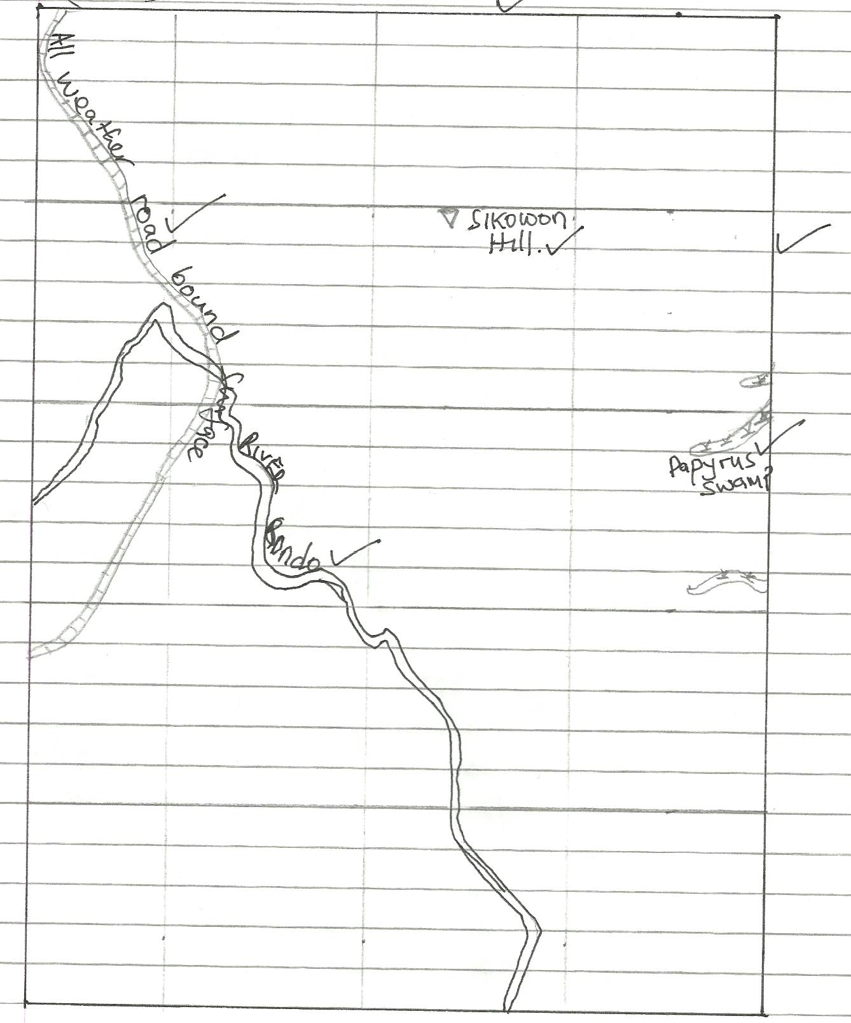
d i) Citing evidence from the area covered name any 2 social activities taking place in Kebenet
- Health as evidenced by a dispensary√
- Education as evidenced by a school√
- Transport as evidenced by the all weather road loose surface√ any 2 x 1 = 2 marks
ii) Give two uses of river Sondo in the area. (2mks)
- For domestic use
- It forms a boundary √ provincial and district 2 x 1 = 2 mks
iii) Explain 3 factors that have influenced the growing tea in the area covered by the map with evidence. (6mks)
- Rainfall as evidenced by permanent rivers for growth of Tea√√
- Transportation as evidenced by the all weather road loose surface for transportation of tea√√
- Labour as evidenced by many settlements for picking tea√√
- Well drained soils as evidenced by spaced contours which favours tea growing√√
- High altitude as evidenced by high contour heights of about 1800m for growth of tea√√
Any 3 x 2 = 6 mks
iv) Name two types of settlement found at grid 2457 (1mk)
- Village settlement
- Huts
- Permanent settlement
Any 2 x ½ = 1 mk
7. a i) 1 - Gregory /Kenyan rift√ 1 mk
2 - Kavirondo√ 1 mk
ii) 3 - Elgeyo√ 1mk
4 - Nguruman√ 1mk
- - Nyandarua√ 1mk
iii) 7 - Magadi 1mk
8 - Turkana 1mk
b) i) - varies in height 600m
- has Lake basins
- has volcanic hills/ridges
- varies in width 100km – 50km 3 mks
ii) Horst
- Crustal rocks are subjected to tensional forces√
- Parallel faults develop√
- The side blocks are downwarped as the middle√ block upward
- The flat topped hill bordered by sleep scarps is a horst√
C i) The rift valley has attracted dense settlements 1 mk
ii) Problems experienced during the study
- steep slopes are difficult to climb
- Inaccessibility in some areas
- Attack from wild animals
- Fatigue from the high temperature 3 x 1 = mks
iii) findings
- Exposes minerals easing mining
- Rainfall the windward slopes - support agriculture and forestry
- Faults pave way for hot spring – tap for Geothermal power
- Fault scarps – provide sites for water fall – tourists attraction & generation of HEP
3 X 1 = mks
8. a) i) Distinguish between soil profile and soil catena
Soil profile refers to the vertical arrangement of soil layers from the surface to the bedrock while soil catena is sequence of different soil types down a slope from the top to the bottom of the hill.√√ (2mks)
Mark as a whole
ii) State two importance of minerals in the soils
- Form the soil framework
- Give anchorage to plants
- Determine the porosity of the soil
- Add minerals to the soil
(any 2x1 – 2 mks)

b i) Explain how the following factors influence soil formation
- Climate
- rainfall provides moisture required for chemical weathering leading to soil formation
- rainfall affects the rate at which soil forming process occur
- seasonal variation of rainfall can cause concentration of salts in the soil
- high temperatures increase the rate of weathering thus accelerate soil formation
- also speed up bacterial activities hence help in decay of organic matter adding humus in the soil
- wind water and ice erosion carry away the top soil leading to formation of this soils
- eroded materials are carried and deposited elsewhere leading to formation of loes and alluvial soils
- Living organism
- Assist in breaking down of rocks through burrowing ploughing and root penetration
- Influence the chemical composition of soils by adding or removing organic acids and minerals
- Burrowing of animals improves soil aeration
- Decay of plant and animal remains add hums and mineral hence influencing soil fertility
(any 3x1 = 3 mks)
c)Describe as a teaching process in soil formation
- Process involving formation of soil rich in carbonate horizon B and C
- Process occur in areas where evaporation exceed precipitation and the parent rock in rich in calcium carbonate
- As evaporation take place, the concentration of salts and bases in the soil solutions increases
- The dissolved substances rise through capillary actions then precipitates in horizon B and calcium bicarbonate change into carbonates forming a crust of calcium compounds within the same profile
d) i) What is soil degeneration?
This is the decline in the usefulness of soil due to soil mismanagement or environmental causes or both
OR
This refers to the loss of soil fertility (1mk)
ii) Identify two types of soil degeneration
- physical degeneration
- chemical degeneration
- biological degeneration
any 2x1 = 2mks)
e) Explain three ways in which vegetation protects the soil from degeneration
- Leaf cover reduce the force of raindrops which would loosen and dislodge the soil particle reducing splash erosion.
- Vegetation cover increases the infiltration of rainwater into the soil thus keeping the soil moist.
- Plant roots penetrating into the soil help to carry moisture into the soil and allow it to gradually percolate deeply.
- Plant cover break the force of wind at the ground level thus reducing loss of soil particles and reduce evaporation which would make soil dry and loose.
- Decayed vegetative matter provide humus which bind soil particles together.
Any 3 explained x 2 = (6mks)

