NAME ____________________________________ INDEX NO. _______________
SCHOOL ____________________________________ SIGNATURE _______________ DATE _______________

312/1
GEOGRAPHY

PAPER 1

TIME: 2¾ HOURS

SET 5
FORM 4

312/1
GEOGRAPHY
PAPER 1
TIME: 2¾ HOURS

INSTRUCTIONS TO CANDIDATES
- This paper has two sections: A and B.
- Answer all the questions in section A.
- Answer question 6 and any other two questions from Section B.
- All answers must be written in the answer booklet provided.
- This paper consists of 4 printed pages.
- Candidates should check the question paper to ascertain that all pages are printed as indicated and that no questions are missing.
- Candidates should answer the questions in English.

SECTION A
Answer ALL questions in this section in the answer booklet provided.
1. a) Name two ocean currents flowing along the African coastline. (2 marks)
b) State three factors that determine the size of a wave. (3 marks)

2. State four factors that determine the amount of solar radiation reaching the earth’s surface. (4 marks)

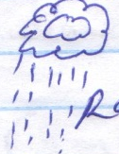
3. The diagram below shows a source of ground water. Use it to answer the questions.

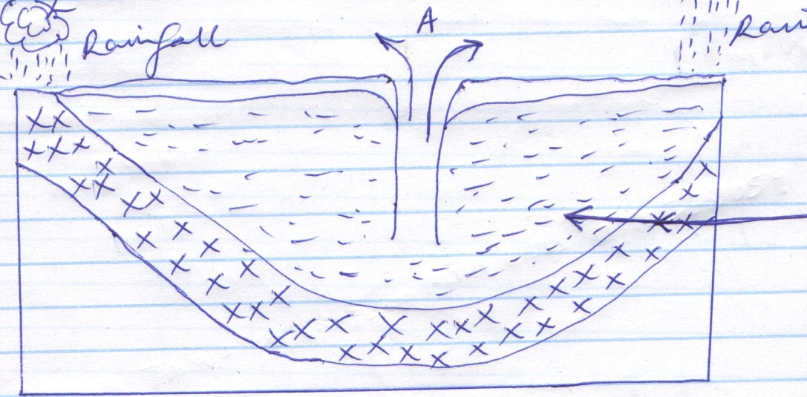
Rainfall
Rainfall
B
A
a) Identify the feature marked A and B. (2 marks)
b) Name two regions in the world where such a feature is found. (2 marks)

4. a) Differentiate between seismic focus and epicenter. (4 marks)
b) i) Name the scale used to measure the intensity of earthquakes. (1 mark)
ii) State two natural causes of earthquakes. (2 marks)

5. a) What is a rock? (2 marks)
b) Give three characteristics of sedimentary rocks. (3 marks)

SECTION B
Answer question 6 and any other two questions from this section in the answer booklet provided.
6. a) i) Give the longitudinal and latitudinal extents of the area covered by the map extract . (2 marks)
ii) Measure the distance of the All-weather road from Thitani to Migwani shops.
Give your answer in kilometres. (2 marks)
b) i) Draw a rectangle measuring 10cm by 11cm to represent the area in the map extract
bounded by Eastings 91 and 11 and Northings 62 and 84. (1 mark)
ii) On the rectangle drawn, mark and name the following:
- Usiani school (1 mark)
- Nzeluni dispensary (1 mark)
- Mutitu health centre (1 mark)
- Dry weather road D507 (1 mark)
c) i) Citing evidence from the map, give two functions of Mutitu (Ndooa) town. (4 marks)
ii) Identify the highest and the lowest points of the area covered by the map. (2 marks)
iii) Give two methods used to represent relief on the area covered by the map. (2 marks)
d) i) Name the type of vegetation found on the grid square 1180. (2 marks)
ii) Give four figure grid reference of the trigonometrical station at Kwamutonya
SKT 33. (2 marks)
iii) Describe the drainage of the area covered by map. (4 marks)

7. a) Differentiate between mass wasting and mass movement. (2 marks)
b) i) State two causes of soil creep. (2 marks)
ii) Explain three factors influencing mass wasting. (6 marks)
c) i) List four processes of chemical weathering. (4 marks)
ii) Describe the following physical weathering processes.
- Slaking (3 marks)
- Exfoliation (3 marks)
d) Students are planning to carry out a field study of on area affected by mass wasting.
i) How did they prepare for the field study? (2 marks)
ii) Identify three follow-up activities. You are likely to undertake after the study. (3 marks)

8. a) i) Distinguish between soil catena and soil profile. (2 marks)
ii) State two ways of managing and conserving soil. (2 marks)
iii) Draw a simple diagram of the soil catena. (3 marks)
b) Explain how the following factors influence soil formation:
i) Nature of the parent rock (3 marks)
ii) Topography (3 marks)
iii) Climate (3 marks)
c) State two characteristics of the following soils:
i) Chernozems (2 marks)
ii) Arenosols (2 marks)
d) Students in your school went out on field study on soils around the school.
i) State three causes of soil degradation they identified. (3 marks)
ii) Name two methods they used to collect information of the above. (2 marks)

9. a) i) State three causes of faulting. (3 marks)
ii) Differentiate between normal fault and reverse fault. (4 marks)
b) i) With the aid of well labelled diagram explain how compressional forces can lead
to the formation of a rift valley. (8 marks)
ii) Give two examples of horst mountains in East Africa. (2 marks)
c) Explain four effects of faulting on human activities. (8 marks)

10. a) i) Distinguish between a river divide and a river basin . (2 marks)
ii) List three types of river erosion. (3 marks)
b) i) Draw a well labelled diagram of the hydrological cycle. (5 marks)
ii) State two benefits of hydrological cycle. (2 marks)
c) i) Describe the following drainage patterns:
- Trellis drainage pattern (3 marks)
- Dendritic drainage pattern (3 marks)
d) You plan to carry out a field study on a river in its youthful stage.
i) State three reasons why you would need to prepare a working schedule. (3 marks)
ii) List two features you are likely to identify during the study. (2 marks)
iii) List two problems you may experience during the study. (2 marks)

