Kenya Certificate of Secondary Education (K.C.S.E)
312/1
GEOGRAPHY
PAPER 1
MARKING SCHEME

a) Name two ocean currents flowing along the Africans coastline
- Aqulhas
- Mozambique warm current
- Warm Guinea current (Any 2x1=2mks).
b) State three factors that determine the size of a wave
- Fetch-distance of open water where the wind blows
- The speed of the wind
- The duration which the wind has been blowing (Any 3x1=3mks)
- State four factors that determine the amount of solar radiation reaching the earth’s surface
- The transparency of the atmosphere / the amount of cloud cover.
- The intensity of the sun’s radiation in the space and the earth’s average distance from the sun
- Position of the earth on its orbit which produces different seasons
- The angle of the surface on which the sun rays fall
- The area and nature of the surface on which the sun rays fall.
(Any 4x1=4mks)

a) Identify the features marked A and B
- Artesian well (1mk)
- Aquifer (1mk)
b) Name two regions in the World where such a feature is found
- Sahara
- West Australia
- Kalahari
- England
- North America Any (2x1=2mks)

a) Differentiate between seismic form and epicentre
- seismic focus is the point of origin inside the earth where shock waves originate while epicenter is the point on the earth’s surface which is vertically above the focus
(Any 2x2=4mks)
b) i) Name the scale used to measure the intensity of earthquakes
mercalh scale (1x1=1mk)
ii) State two natural causes of earthquakes
- tectonic movement
- gravitational pressure
- excessive energy release in the mantle
- vulcanicity Any (2x1=2mks)

a) What is a rock?
A rock is a naturally occurring agglomeration of mineral particles forming the solid part of the earth’s crust (2x1=2mks)
b) Give three characteristics of sedimentary rock
- they are non-crystalline
- they are arranged in layers/ strata
- they contain fossils
- they are derived from sediments of other rocks Any (3x1=3mks)

SECTION B

a) i) Give the longitudinal and latitudinal extends of the area covered by the map extract
Latitudinal extend 1º05¹-1º15’s
Longitudinal extend 38º 05¹-38º10¹ E
(2 x 1 = 2marks)
ii) Measure the distance of the all weather road from Thitani to Migwani shops. Give your answer in Kilometres
4.3 $±0.1$km (2x1=2mks)

b) A rectangle measuring 10cm by 12cm representing area between eastings 91 and 12 and Northings 62 and 84
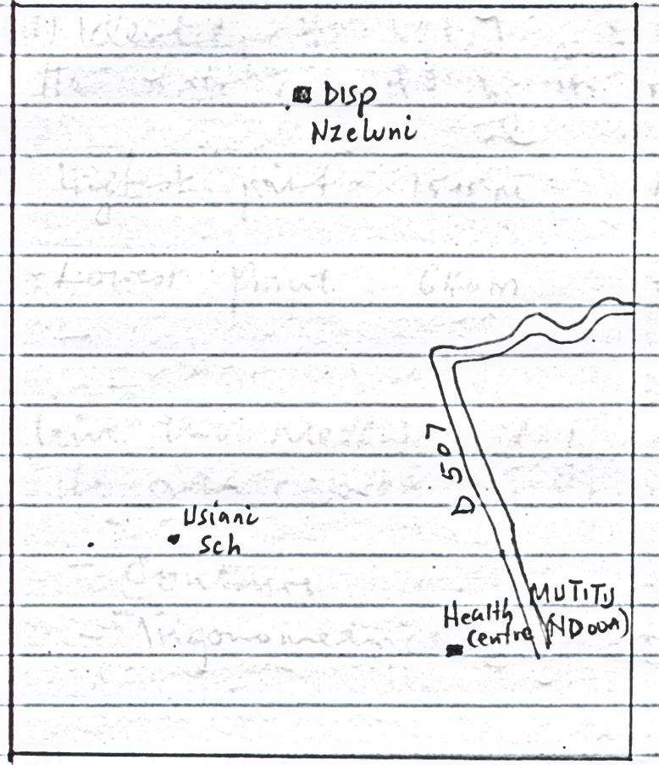
Usiani school (1mk
Nzeluni dispensary (1mk)
Mutitu health centre (1mk)
Dry weather road d 507 (1mk)
Correct dimension and measurement 1 mk
c) i) Citing evidence from the map give three functions of Mutitu (NDOOA) town
- Education function due to presence of school
- Administrative function due presence of chief’s office
- Communication function due to presence of post office
- Religious function due to presence of church office
- Health function due to presence of health center.
Any 2 x 2 = 4 marks
ii) Identify the highest and lowest pints of the area covered by the map.
- Highest point 1515m (1mk)
- Lowest point 640m (1mk)
iii) Give two methods used represent relief on the area covered by the map
- Contours
- Trigonometric stations (2x1=2mks)

d) i) Name the type of vegetation found on the grid square 1180
- Scrub
- Scattered trees (2x1=2mks)
ii) Give four figure grid reference of the trigonometrical station at Kwamutonga SKT 33
9374 (1x2=2mks)
iii) Describe the drainage of the area covered by the map extract
- Migwani has permanent rivers for instance river Vinda
- The main rivers Ngoo and Ikoo
- The rivers form dendritic drainage pattern for instance river Ikoo
- There are parallel drainage pattern in some rivers such as upper course of Ikoo
- There are disappearing rivers near Mutito forest
- There are dams Kisini and Mboni dam Any (4x1=4mks)
- Difference between mass wasting and mass movement
a) Mass wasting is the down ward movement of weathered materials under influence of gravity while mass movement is the movement of lubricated materials down slope.
1x2=2 mks
b) i) Causes of soil creep
- alternate heating and cooling of soil
- alternate drying and wetting of soil
- ploughing down slope
- removal of soil down slope
- earth quakes (Any 2x1=2mks)
ii) Factors influencing mass wasting
- slope- steep slopes facilitate faster movement
- nature of materials- massive rocks can slide or move easily
- amount of water- Saturated materials move faster than dry ores
- climate- areas receiving heavy rainfall experience movement of materials
- absence of vegetation – facilitate movement
- tectonic forces – Cause widespread movement of materials
- use of explosive – in mining causes downward movement
(Any 3x2=6mks)

c) i) Processes of chemical weathering
- carbonation
- hydrolysis
- hydration
- oxidation
- solution (Any 4x1=4mks)
ii) Slaking
- Rocks take up the rain water during the wet season
- During the dry season, rocks loose this water through evaporation and the rock eventually dries, shrinks and fractures or breaks up.
- This breaking mainly affects rocks containing clay (3mks)
Exfoliation
- First the rock masses are subjected to heat from the sun
- Then the rock surface becomes much hotter than the interior
- The difference make the rocks to expand and contract on the surface hence cracks develop
- The surface of the rock peels off like ;onion
- This process of weathering is called exfoliation (3mks)
d) i) Preparations for the study
- Seeking permission for the study
- Conducting pre-visit
- Revising statement of objectives and hypothesis
- Choosing methods of data collection
- Assembling research equipment
- Preparing a working schedule. (Any 2x1=2mks)
ii) Identify three follow up activities you are likely to undertake after the study
- Compiling notes
- Displaying the labeled samples/ photographs
- Presenting findings of the study / field report
- Class / group discussions
- Data analysis (Any 3x1=3mks)
8.
a) i) Distinguish between soil catena and soil profile
Soil catena is sequence or arrangement of different soils on a mountain slope from top to the bottom while soil profile is the vertical arrangement of various soils in layers from the surface to the bedrock Distinction of the two (2x1=2mks)

ii) Ways of managing and conserving the soil
- Tree planting
(afforestation and reafforestation)
- Mixed farming (keeping animals and plants)
- Contour ploughing
- Keeping adequate number of animals livestock in relation to the land size
- Crop rotation
- Terracing slopping land (Any 2x1=2mks)
iii) Soil catena
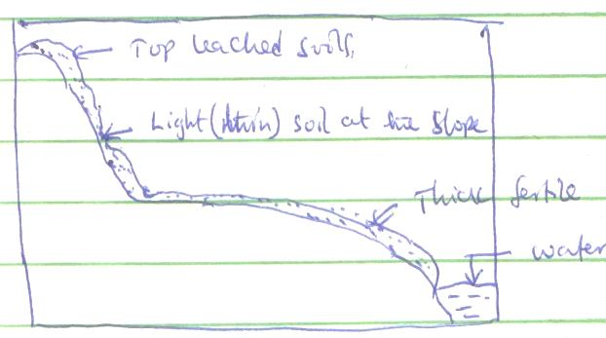
1
Thick fertile soils at the bottom
1
1
Water
Light (thin) soil at the slope
Top leached soils
(3mks)
b) Factors that influence soil formation
i) Nature of parent rock
- Parent rock determines the type of soil formed
- It also determines the type of weathering depending on the mineral composition
- The parent rock determines the mineral composition of the soil thereby determining its fertility (3mks)
ii) Topography
- The nature of the slope determines the type of soils
- Soil on top of hills are heavily leached. There are deep and fertile soils in plain and valley bottoms
- Poorly drained or marshy areas have poor soils which are water logged (3mks)
iii) Climate
- Places with heavy rainfall have heavily weathered soil material and are also heavily leached thus deep soils
- Rainfall leads to formation of alluvial soils through deposition along rivers
- High temperature promote weathering
- Low temperatures slow the weathering processes
- Variation in temperature determines the type of soil organism in an area
- Climate determines vegetation which is turn has an effect on soil
(3mks)
c) i) Characteristics of chernozems
- They are dark coloured
- They have a relatively high organic content
- Have a calcerous sub-soil
- They have well drained and have loose crumbled texture
- They are rich in minerals (Any 2x1=2mks)
ii) Aeronosols
- They are largely composed of sand or quartz
- The top soil has low organic matter and therefore less fertile
- Common in the coastal areas (Any 2x1=2mks)
d) i) Causes of soil degradation they identified
- High population increase
- Overgrazing
- Burning of land/charcoal burning
- Poor farming methods
- Nature of climate
- Nature of landscape
- Mon-cropping / mono- culture. (Any 3x1=3mks)
ii) Methods used to collect information
- Observation
- Sampling
- Photographs (Any 2x1=2mks)
9.
a) i) Causes of faulting
- Earth movement that cause tension within rocks
- Earth movements that cause compression within rocks
- Shearing of rocks
- Vertical movement of the rocks that cause them to fracture (Any 3x1=3mks)
ii) Difference between normal fault and a reverse fault
- Normal fault is caused by tensional forces while reverse fault is caused by compressional forces
- In a normal fault a part of the fault plane is exposed to form an escarpment while in a reverse fault the fault plane is not exposed to the surface
- In a normal fault up throw moves away from down throw while in a reverse fault the up throw rides over down throw. (Any 2x2=4mks)
b) i) Formation of rift valley by compressional forces
- Layer of rocks are subjected to compressional forces
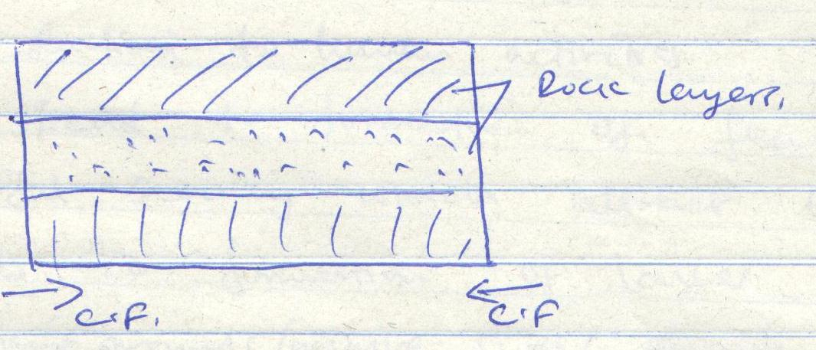
- Two reverse faults develop in the rocks of the crust
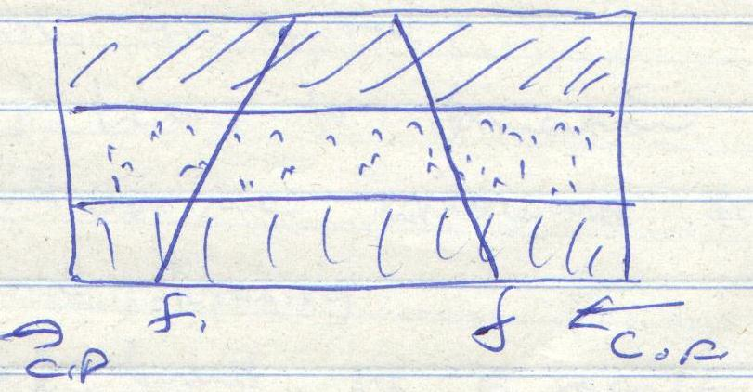
- The outer blocks of land are thrust above the middle along the fault planes
- The middle block either sinks or remains static but a lower level
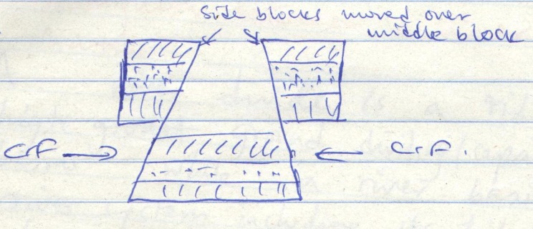
- The protruding parts are removed by erosion or may collapse to form the fault scarps
- The sunked middle part forms a depression called a rift valley.
Diagrams (4 x 1 = 4marks)
Explanations (4 marks)
ii) Examples of horst Mts in E. Africa
- Pare Mts
- Usambara mountains
- Ruwenzori Mountain (Any 2x1=2mks)

iii) Effects of faulting to human activities
- Faulting may lead to formation of features that form beautiful scenery which attract tourist.
- Faulting leads to formation of lakes that are important fishing grounds/ mining sites/ provide water for irrigation/ for domestic use/ industrial use
- Faulting cause displacement of rocks which exposes minerals that are mined
- Faulting may lead to formation of mountains which attract rainfall on the windward side which favours agriculture and forestry
- Subsidence of land as a result of faulting may lead to loss of life and property
- Faulting and resultant fault scarps make it difficult to construct roads and railways
10.
a) i) Distinguish between river divide and river basin
A river divide is a ridge or a strip of high ground dividing/ separating two drainage basins while a river basin is the entire river system including its tributaries and distributaries/ the total area drained by a river and its tributaries (2x1=2mks)
ii) List three types of river erosion
- Headward erosion
- Vertical erosion
- Lateral erosion (3x1=3mks)

b) i) Draw a well labeled diagram of the hydrological
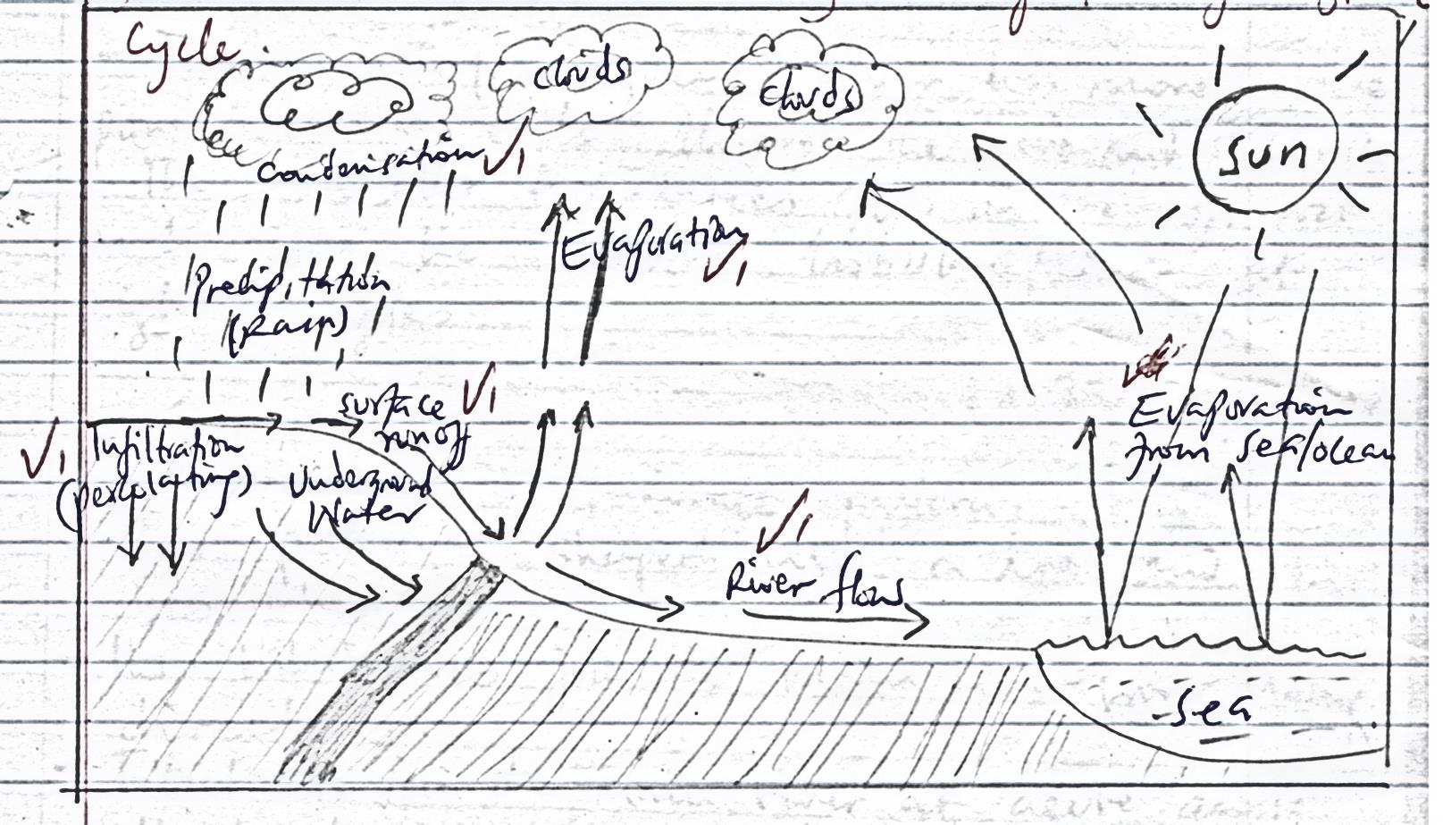

ii) State two benefits of hydrological cycle
- Moisture in the atmosphere regulates the heat being lost from the ground by reflecting most of it back thus keeping the lower atmosphere warm
- Water supports existence of life on earth
- Helps to provide underground water through percolation which when released to the surface through wells/spring can be used for domestic and industrial use (Any 2x1=2mks)
c) i) Describe the following drainage patterns
- Trellis drainage pattern
- Develops in Areas with alternating hard and soft rocks and where the land dips towards the same direction
- The main/consequent river has more erosive power hence cuts through the hard and soft rocks.
- The smaller tributaries flow on the soft rocks and join the main tributary/river at right angles (3x1=3mks)

- Dendritic drainage pattern
- This pattern is shaped like a tree and its branches
- Its tributaries join the main river from many directions
- Tributaries join the main river at acute angle
- It develops in areas with uniform rock hardness and structure
d)
i) State three reasons why you would need to prepare a working schedule
- It helps in adequate allocation of time to each activity so no activity is forgotten
- It reduces the tendency to waste time and forces the researchers to work within the stipulated time and complete the study as scheduled
- It provide an estimate of the time required for the study
- It provides a basis for evaluating the field work while it is still in progress
- It provides a framework that guides the researcher to remain within the scope of the topic
(Any 3x1=3mks)
ii) List two features you are likely to identify during the study
- V- shaped valleys
- Waterfalls and rapids
- Gorges
- Interlocking spurs
- Pot holes (Any 2x1=2mks)
iii) List two problems you may experience during the study
- Attacks by wild animals crossing the river valley
- Hindrance by poor weather conditions e.g. sudden rains
- Accidents e.g. slipping
- Difficulties in accessing some of the areas due to the rugged terrain
- Thick vegetation (Any 2x1=2mks)

