Kenya Certificate of Secondary Education (K.C.S.E)
312/1
GEOGRAPHY
PAPER 1
MARKING SCHEME

SECTION A

a) Geo means the earth’s surface (1mk)
b) Areas of great interest to a physical geographer
- The earth and the solar system
- The internal land forming processes
- The external land forming processes
- Weather and climate
- Soil
- Vegetation 4 x 1 = 4mks

a) Two plains in Kenya
Kano, Coastal plains, Yatta plateau, Uasin Gishu, Athi-Kapiti plains
2 x 1 = 2mks
b) Ways in which plains are formed
- Through folding if compressional forces are weak the landscape may be turned into gently sloping anticlines and synclines
- Through volcanic eruptions where less viscous lava flows forming a plateau
- Due to river deposition in the old stage forming flood plains.
- Through waves deposition on the coast
- Through slope retreat or pediplanation
- Through glacial deposition of till plains and out wash
- Through erosion in areas where geomorphic cycle has been able to run its course without interruption
3 x 1 = 3mks

a) Types of local winds
- land and sea breezes
- katabatic winds and anabatic winds
- fohn winds
2 x 1 = 2mks
b) How land breeze occurs
- at night land cools faster than water bodies
- air in contact with water is warmed, becomes lighter and rises
- due to pressure differences, air blows from the land to the sea to replace the rising warm air
3 x 1 = 3mks

a) River capture- it is the diversion of the head waters of a weak river system into an adjacent neighboring more powerful river. (2 mks)
b) Evidences of river capture
- misfit stream (beheaded river)
- elbow of capture
- wind gap (dry valley)
- incision of the valley of the pirate river
3 x 1 = 3mks

a) i) Feature N is the horn (1mk)
ii) Air current marked P are wind eddies (eddying winds) (1 mk)
iii) Formation of barchans
- formed by wind deposition
- an obstacle on the wind path causes accumulation of sand
- due to wind fluctuation, crescent like dune occurs transversely to the wind with its horns trailed out in the direction of wind
3 x 1 = 3mks

SECTION B

a) i) Type of map - Topographical map (2mks)
ii) Height of the highest point on the area 1515m (2mks)
iii) Two types of natural vegetation on the area
- Scattered trees.
- scrub vegetation
2 x 1 = 2mks
iv) Direction of Kauma dam from Usiani school SW (1mk)
Bearing of Kauma dam from Usiani School
220°$± 1=219° to 221°$ (2mks)

b)

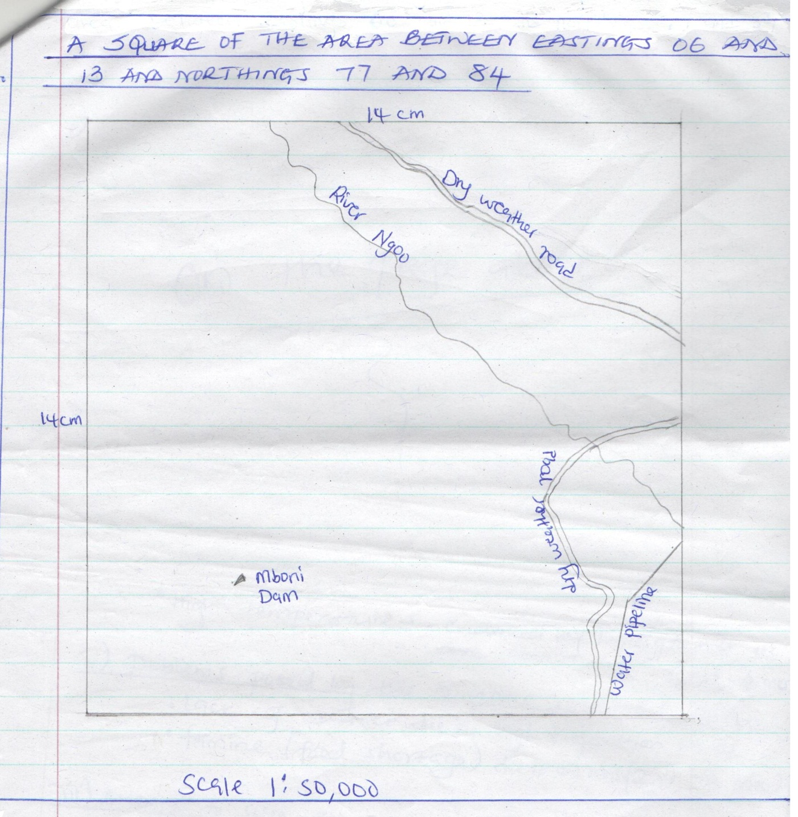
- Square dam – 1mk
Dry weather road – 1mk
Mboni dam – 1mk
Water pipeline – 1mk
R. Ngoo – 1mk

- i) Climate of the area
- low unreliable rainfall- evidenced by scattered trees and scrub vegetation
- high temperatures-evidenced by bares grounds in some areas
2 x 2 = 4mks
ii) Problems posed by the climatic conditions above
- lack of water due to high evaporation rates
- famine (food shortage) due to low rains
2 x 1 = 2mks
iii) Attempts to solve the problem (cite evidence)
- digging of dams in some areas e.g Kauma dam
- water pipeline in the eastern parts of the /map has provided water to the people in that area
- digging of bore holes to supply water e.g. near R. Ikoo
(NB: The water can be used for domestic purposes or for irrigation
2 x 1 = 2mks
- topography of the region
- The areas slopes from the west to the East
- The western and central parts are hilly and rugged
- The eastern area is gently sloping
- The highest point is at Kamutothya with a height of 1515 m
3 x 1 = 3mks

a) i) How a tarn is formed
- slow accumulates in a shallow pre-existing depression on a mountain side and gets compacted into ice to form a cirque glacier
- ice erodes the bottom of the hollow by abrasion, making it deeper
- frost action and the plucking process operate on the sides of the hollow making lit wider and on the back wall making it deeper
- Eventually a deep armchair-shaped depression is formed called a cirque. The depression is later filled with rainwater or melt water or both forming a lake called a tarn.
4 x 1 = 4mks
ii) Areas in East Africa where tarns are found
- Mt Kenya
- Ruwenzori ranges
2 x 1 = 2mks
b) External land forming processes that lead to formation of lakes
- Weathering by solution in limestone areas
- Erosion by wind, ice and river
- Deposition by water or ice
- Mass movement.
- Failing of meteorites
- Glaciations- through glacial erosion
- Human activities through damming of rivers and blowing up of land with explosives
5 x 1 = 5mks
c) Effects of the following on lakes in Kenya
i) Deforestation
- Expose the land to agents of erosion. The eroded soil is carried into lakes where it causes siltation. This reduces the depth of the lakes
- Deforestation in the water catchment areas, interferes with the hydrological cycle which leads to lower rainfall and less water in the feeder rivers. Eventually the lakes may dry up.
2 x 1 = 2mks
ii) Industrialization
- Increased industrialization and disposal of industrial waste into the lakes leads to pollution of lake water
- Accumulation of agro-chemicals and industrial effluent which are washed into the lakes promotes weeds, blooms. As a result, the lakes are colonized by weeds.
2x 1 = 2mks

iii) Water weeds
- Waterweeds such as water hyacinth choke the lakes thus hindering effective exploitation of the resources in them.
- They also hinder transportation on the lakes
2 x 1 = 2mks
d) Four ways by which human activities threaten the existence of lakes in Kenya essive drawing of water for irrigation reduces the volume of water in some lake which may led to their drying up e.g. L Naivasha
- Disposal of industrial and domestic waste and effluent contaminates some lakes and this may cause extinction of some aquatics life e.g in L. Nakuru and L. Victoria
- Introduction of weeds on land for scientific research may lead to some of these weeds finding their way to the lakes. They colonize the lakes and turn them into swamps e.g. L. Victoria and L. Naivasha. The Nairobi. Dam is now a swamp
- Soil erosion on land caused by ;increased human activities has led to the silting up of some lakes e.g Masinga and Kindaruma dams
- Deforestation/ destruction of vegetation in the water catchment, areas interferes with the hydrological cycle which eventually leads to drying up of lakes
- Damming of feeder rivers for irrigation and hydro-electric power production reduces the water reaching the lakes hence causing lakes to shrink.
4x 2 = 8mks
8.
a) i) Distinguish between a spring and a well
A spring is a place on the surface of the earth where underground water flows out onto the surface. A well is a deep hole in the ground, usually dug by people for the purpose of getting water (2mks)
ii) Sources of underground
- rainwater
- melt water
- lake and sea water
- magmatic water (plutonic water)
3 x 1 = 3mks
b) How factors influence existence of underground water
i) Nature of rocks
- for surface water to infiltrate and percolate through the rocks and eventually accumulate to form underground water, there must be air spaces in the rocks in form of pores, cracks or joints, Porous or pervious rocks increase the rate of infiltration and precipitation
- Likewise the aquifer should be porous of previous or both. It must be underline by an impermeable rock both. It must be underlain by an impermeable rock so that underground water can accumulate in it.
- x 1 = 2mks
ii) Vegetation cover
- The presence of vegetation cover increases amount of water infiltrating the ground and ultimately the amount of underground water reservoir
- Vegetation breaks the speed of raindrops falling on the ground gently and have time infiltrate
- Vegetation reduces the speed of surface run-off and thus increasing infiltration rate
- The presence of vegetation also increases retention of underground water by providing shade on the ground and reducing direct loss of water from the ground through evaporation.
2 x 1 = 2mks
c)
i) Artesian well (1mk)
Is a hole sunk into the ground in an artesian basin and from which water comes to the surface on its own.
ii) Conditions ideal for formation of artesian wells.
- The aquifer must lie between impermeable rocks so as to be able to retain water.
- The aquifer must out crop in a region which is a source of water, like a rainy area or beneath a lake
- The aquifer must dip from a region of water intake and form a broad syncline
- The mouth of the well must be lower than the intake area ;to- ensure water comes out of the well on its own 3 x 2 = (6mks)
- Diagram of an artesian
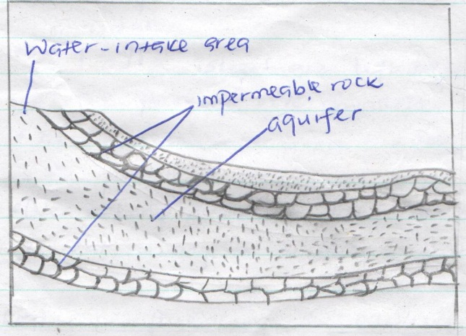
Diagram 2mks
Water intake area 1mk
Aquifer 1mk
Impermeable rock 1mk
- Problem associated with artesian wells
- The water in some of the wells is salty or may be hot making it unsuitable for drinking or irrigation
- If the water is drawn faster than it is being replaced the level may go down and the well ceases to be of the artesian type.
2x2=4 mks
9.
a) i) Factors causing soil creep
- alternate heating and cooling which causes expanding and contracting of soil particles hence shifting their position
- Alternate drying and wetting of soil particles causing them to break away from each other
- Removal of soil downslope
- Rain water- drags individual soil particles along causing them to change positions
3 x 1 = 3mks
ii) Effects of soil creep
- Pushes posts and fences from their original position, making them inclined
- Exerts pressure on stone walls causing them to crack or break
- Steep upper slopes are left bare and exposed as fine particles move downslope
- At the destination area at the base of the slope soil particles accumulate forming deep soil
- Over a long period of time soil creep leads to slope retreat, causing it to become gentler.
4 x 1 = 4mks
b) i) Conditions influencing the occurrence of landslides
- Amount of precipitation in the area and therefore extent of saturation-heavy rainfall encourages landslides
- The gradient of the land-steep slopes are more prone to landslides
- Human activities such as mining and construction
- Occurrence of earthquakes and volcanic eruptions which causes movement of materials.
2 x 1 = 2mks
ii) Forms ‘of landslides
- Slump
- Rock fall
- Rock slide
- Debris fall
- Debris slide
3 x 1 = 3mks
iii) Other forms of rapid mass wasting
- Earthflows
- Mud flows
- Avalanches
2 x 1 = 2mks
- i) Type of mass movement shown
Rock fall (1 mk)
ii) Features M- Cliff (1mk)
N- Talus / rock debris (1mk)
- Effects of mass wasting on the physical environment
- Results in formation of scars on the land where materials break away from the hill slide
- Can trigger off soil erosion, the scars left behind expose the soil to agents of erosion
- Can lead to formation of new land forms e.g. when slumping occurs, depressions may be formed
- Landslides can lead to blockage of rivers causing them to change their direction of flow
- Mass of materials of a landslide can accumulate across a river valley eventually forming a lake on the upstream side
- x 2 = 8mks
10.
a) i) Earthquake – Is a sudden and rapid movement or tremor of the earth crust (2mks)
ii) Cause of earthquakes
- Movement of tectonic plates – tectonic movements cause tectonic plates to meet and lock temporarily. Stress builds up near their edges and eventually the rock fracture. There is sudden release of energy when the rocks fracture which triggers earthquakes.
- Vulcanicity- Violent movements of magma within the rocks of the earth’s crust can cause tremors due to the crustal rocks being displaced suddenly.
- Gravitative pressure – When magma escapes to the surfaces the rocks overlying the chambers that once contained magma are under great pressure from the force of gravity which is pulling them inwards. The rocks may eventually sink and set off vibrations at the same time. .
- Sudden energy release in the mantle- radioactivity taking place in a localized area within the mantle may result in the release of excessive energy which could be explosive. The resultant explosions are due to nuclear fission and they send shock waves outwards into the crustal rocks, which cause them to shake.
- x 2 = 6mks
b) i) Illustration to distinguish between seismic focus and epicenter
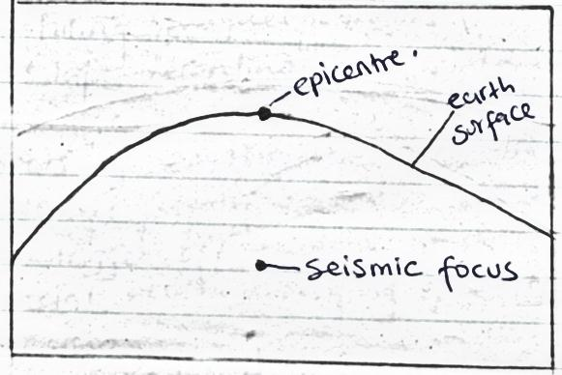
Illustration (2 maks)
Seismic focus (1mk)
Epicentre (1mk)
ii) Types of earthquakes waves
- primary (P-) waves
- secondary (S-) waves
- Raleigh waves
Long waves (L- waves
- love waves
2 x 1 = 2mks
- i) Formulate a null hypothesis
- earthquakes were not caused by volcanicity in the area
- there was no major destruction caused by earthquakes
1 x 1 = 1mk
ii) Reasons for conducting a pre-visit
- to familiarize themselves with the area of study
- helps in identifying methods of data collection
- helps in estimating the cost of the study
- to determine appropriate routes to the area
- Helps in preparing a working schedule.
2 x 1 = 2mks
iii) Methods of recording data
- Taking photographs
- Taking notes
- Filling in questionnaires
- Tape recording
2 x 1 = 2mks
- Effects of earthquakes on human environment
- Destroys property and can lead to loss of human life
- Can trigger off tsunamis which can cause flooding of coastal areas destroying property and also causing deaths
- The vertical and lateral displacements of land which are caused by earthquakes cause damage to transport and communication lines
- Earthquakes can spark off landslides which in turn damages property and leads to loss of life

