312/2
GEOGRAPHY
PAPER 2
TIME: 2 ¾ HOURS

SET 9
FORM 4

GEOGRAPHY
PAPER 2
2 ¾ HOURS

INSTRUCTIONS TO THE CANDIDATES
- This paper has two sections: Section A and B.
- Answer all the questions in section A.
- Answer question 6 and any other two questions from section B.
- All answers must be written in the answer booklet provided.
- Candidates should answer the questions in English.

This paper consists of 3 printed pages.
Candidates should check the question paper to ascertain that all pages are printed as indicated.
And that no questions are missing.

SECTION A
Answer all the questions in this section.
1. (a) State any three physical factors that influenced the location of Owen Falls in Uganda.(3 mks)
(b) Identify any two non-renewable sources of energy. (2mks)
2. (a) Define the term balance of trade. (2 mk)
(b) Give three reasons why Kenya experiences unfavourable balance of trade. (3 mks)
3. (a) What is agroforestry. (2 mks)
(b) State three reasons why agroforestry is encouraged in Kenya. (3 mks)
4. (a) Briefly explain the meaning of tourism. (2 mks)
(b) State three reasons why domestic tourism is being encouraged in Kenya. (3 mks)
5. (a) Define arable farming. (2 mks)
(b) Apart from tea, name other three crops grown on a large scale in the highlands east of the Rift
Valley in Kenya. (3 mk)

SECTION B:
Answer question six and any other two questions.
6. The table below shows four proportional crops produced in Kenya in the years 2000-2002. Use it to
answer the questions that follow.

CROP | AMOUNT IN METRIC TONNES
 | 2000 | 2001 |  | 2002
Wheat  Maize  Coffee  Tea | 70,000  200,000  98,000  240,000 |  | 130,000  370,000  55,000  295,000 | 120,000  400,000  40,000  315,000

- (i) Using a scale of 1 cm to represent 50,000 metric tonnes, draw a comparative bar graph based on the data above. (8 mks)
(ii) State two advantages of using comparative bar graphs. (2 mks)
(iii) Calculate the percentage increase in tea production between the years 2000 – 2002. (2 mks)
- State four reasons why cash crops are mainly grown in Kenyan highlands. (4 mks)

- (i) Describe how maize is grown in Kenya from cultivation to harvesting. (7 mks)
(ii) Name the common pests that attack maize. (2 mks)
7. (a) (i) Define the term industrial inertia. (2 mks)
(ii) State four reasons for decentralization of industries. (4 mks)
(b) (i) Explain four factors which influenced the location of iron and steel industry in the Ruhr
region of Germany in the 19th century. (8 mks)
(ii) Name three industries found in the Ruhr region. (3 mks)
- You intend to carry out a field study of a factory which manufactures goods for a local market as well as for export.
(i) State the background information you would need for the study. (3 mks)
(ii) Give two reasons why content analysis may not be suitable method of data collection during
the field study. (2 mks)
(iii) What information would you collect to enable you achieve the objectives of your study.
(3 mks)
8. (a) (i) Define a canal. (2 mks)
(ii) Name two canals found in Africa. (2 mks)
(iii) State four advantages of human porterage. (4 mks)
(b) (i) Outline the causes of decline in the use of letter writing as a means of communication in
Kenya. (4 mks)
- Explain four major efforts being made to solve the problems facing transport in Africa.
(8 mks)
- What are the disadvantages of containerization. (5 mks)

9. (a) Explain the factors that have contributed to the high population growth rate in Kenya. (6 mks)
(b) Explain why a high rate of population growth in Kenya is likely to slow down economic
development in the country. (6 mks)
(c) (i) What is meant by overpopulation. (2 mks)
(ii) Apart from rural-rural migration, state three other types of migration. (3 mks)
(iii) Explain four causes of rural-rural migration in Kenya. (8 mks)
10. (a) Name three major minerals mined in Kenya. (3 mks)
(b) (i) Describe the open cast method of mining. (4 mks)
(ii) Explain how the following factors influence mining.
- Value of the minerals. (2 mks)
- Mode of occurrence (2 mks)
- World market prices (2 mks)
(c) Explain four ways in which Kenya has benefited from mining trona on L. Magadi. (8 mks)
(d) Give four by products obtained when crude oil is refined. (4 mks)

312/2 GEOGRAPHY PAPER 2
MARKING SCHEME

SECTION A
1. (a) (i) Factors that influenced the location of Owen Falls power project.
- Constant volume of water throughout the year from L. Victoria which is a natural reservoir.
- Presence of hard basement rock for a firm foundation of the dam.
- Availability of space for a reservoir to form.
- Large local market as well as foreign market in Kenya for H.E.P
- There is adequate capital for the project.
- Presence of natural waterfalls.
(ii) Non- renewable sources of energy.
- Coal or peat
- Petroleum
- Natural gas
- Uranium
2. (a) Balance of trade is the difference in value between a country’s visible exports and visible
imports.
(b) Why Kenya experiences unfavourable balance of trade.
- Kenya exports mainly agricultural products which are of low value and imports
manufactured goods which are of high value.
- Kenya’s expenditure on imported goods is high due to increased prices of crude oil,
petroleum products and industrial machinery as well as fertilizers.
- The agricultural products exported from Kenya face stiff competition in the world market, leading to reduced sales and less earnings.
- The imposed quota system sometimes leads to reduced sales and less earnings.
-Some exported are of low quality hence generate little income
3. (a) Agroforestry is a land use system where there is growing of trees and crops on the same
piece of land at the same time.
(b) Why agroforestry is being encouraged.
- To ensure continuous supply of wood, fuel, timber, herbal medicines and raw materials for
making paper.
- To reduce importation of forest products hence save foreign exchange.
- To create employment opportunities.
- To protect soil from erosion.
- To protect and improve water catchment areas.
- To maintain the hydrological cycle of water.
- To create scenic beauty.
- To expand habitat for wildlife and conserve wildlife.
4. (a) Tourism is the practice of visiting places of interest for recreational purposes and to some
extend for business or education.
(b) Why domestic tourism is being encouraged in Kenya.
- To make use of tourist facilities during the low tourist seasons.
- To make Kenyans know more about their own country and appreciate their national
heritage.
- To facilitate interaction and cultural exchange among different communities and thus enhance national unity.
- To expose people to locally produced artifacts.
- To expose Kenyans to a wider variety of recreational facilities.
- To create employment.
5. (a) Arable farming is the cultivation and management of crops.
(b) Crops grown on a large scale in the highlands east of the Rift Valley.
- Coffee
- Rice
- Pineapples
- Wheat
- Barley
6. The table below shows four proportional crops produced in Kenya in the years 2000 – 2002. Use it to
answer the questions that follow.
CROP | AMOUNT IN METRIC TONNES
 | 2000 | 20001 | 20002
Tea  Maize  Coffee  Wheat | 240,000  200,000  98,000  70,000 | 295,000  370,000  55,000  130,000 | 315,000  400,000  40,000  120,000
- (i) Using a scale of 1 cm to represent 50,000 metric tonnes, draw a comparative bar graph based
on the data above. (8 mks)
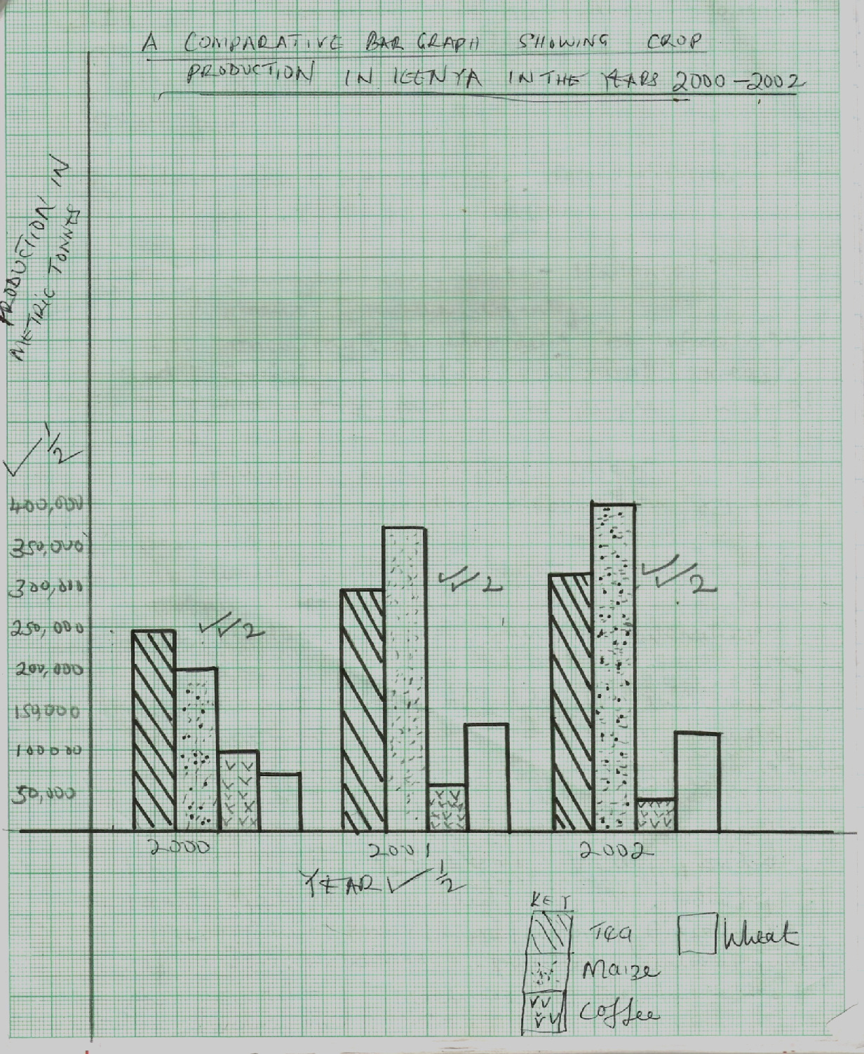

(ii) State two advantages of using comparative bar graphs. (2 mks)
- They allow ease in comparison / interpretation.
- They give clear visual impression.
- They are easy to read.
- They easily show the trend of the given data.
- They are easy to draw/construct. (Any 2 x 1 = 2mks)

(iii) Calculate the percentage increase in tea production between the years 2000 – 2002
(2 mks) 315,000
-240,000
75,000
75 000 x 100 ¹
240,000 = 31.25% ¹
(b) (i) State four reasons why cash crops are mainly grown in Kenyan highlands. (4 mks)
- The cool climate to warm climate conditions.
- The moderate to high rainfall received annually.
- The soils in the highlands are volcanic/loamy for crops cultivation.
- Population is high in the highlands providing labour in the farms.
- The early settlers and colonial government introduced cash crop farming in the highlands.
-The dry sunny period between the rainy seasons
(c) (i) Describe how maize is grown in Kenya from cultivation to harvesting.
- The land is cleared and ploughing done to medium tilth.
- Seeds are sown manually by hand or mechanically by planters at onset of rain.
- Two seeds are sown in each hole at a depth of 2.5 – 5 cm in moist soil and 10 cm in dry
soils.
- Fertilizer is applied during planting.
- Gapping and thinning is done to remove /weak seedlings.
- Nitrogenous fertilizers are added when the crop is 30 – 35 cm high/immediately after weeding.
- The crop is ready for harvesting in 4 – 12 months depending on the variety and the altitude. (7 x 1 = 7 mks)
(ii) Name the common pests that attack the maize. (2 mks)
- Stalk bore
- Army worms
- Aphids
- Birds
- Weevils
7. (a) (i) Define the term industrial inertia. (2 mks)
- It is the tendency of an industry to remain at a given place even after the initial factors of its
establishment are no longer existing.
(ii) State four reasons of decentralization of industries in Kenya. (4 mks)
- To encourage regional balance in development in the country.
- To encourage development of infrastructure and social amenities in rural areas.
- To create employment to people in rural areas.
- To reduce rural – urban migration.
- To allow grater exploitation of local resources.
- It would help reduce congestion in urban areas.
- It reduces risks during calamities.
(b) (i) Explain four factors which influenced the location of iron and steel industry in the Ruhr region of Germany in 19th century.
- Availability of coal, iron ore as well as limestone from the Rhine Valley provided raw
materials needed in the industry.
- River Rhine/Ruhr/Lippel/ Wopper/Emschar and its distributaries provided water required for cooling machines in the industries/ industrial use.
- The region is served by navigable rivers and canals which provide cheap transport for the bulky raw materials and finished products.
- Coal and petroleum had acquired skills on iron working/availability of skilled labour and thus formed the foundation of iron and steel industry.
- Presence of rich families ie krupp Ruhr kohle and companies which provided capital for the development of the country.
- The dense and affluent population in central and western europe provided ready market for iron and steel. (Any 4 x 2 = 8 mks)
(ii) Name three industries found in the Ruhr region. (3 mks)
- Chemical
- Iron and steel
- Electronics
- Food processing
- Oil refining
- Engineering
- Service industries (Any 3 x 1 = 3 mks)
(c) You intend to carry out a field study of a factory which manufactures goods for a local
market as well as for export.
(i) State the background information you would need for this study.
- Lesson and discussions on manufacturing industries.
- Knowledge about population densities and distribution in the area around the factory.
- Reading written documents about manufacturing industries. (3 x 1 = 3 mks)
(ii) Give two reasons why content analysis may not be suitable method of data collection
during a field study.
- It is difficult to verify the accuracy of available data.
- The data, may be out of date and therefore irrelevant to current trends.
- Upto date information may be lacking. (any 2x1=2mks)
(iii) What information would you collect to enable you achieve the objectives of your
study.
- Sources of raw materials for the factory.
- Sources of raw materials and power for the factory.
- Types of goods made at the local factory.
- Where the products of the factory are sold
- The means of transporting raw materials to the factory.
- The number of people employed on the factory.
- The source of labour.
- The type of skills that workforce possesses. (3 x 1 = 3 mks)
8. (a) (i) Define a canal. (2 mks)
-These are artificial waterways constructed to permit the passage of vessels from one large water body to another. (2 mks)
(ii) Name two canals found in Africa.
- Suez Canal
- Jonglei canal (2 x 1= 2 mks)
(iii) State four advantages of human porterage. (4 mks)
- It’s a cheap means of transport.
- It does not result in pollution unlike other means of transport that emit fumes from their engines.
- It provides employment opportunities to many people e.g. porters, hand crafts.
- This means of transport not require specialized training.
- It is not a susceptible to delays that are usually caused by traffic jams or congestion.
- It is convenient in that it is almost always available where there are people.
- It can be used anytime when needed as there are no fixed schedules to follow, therefore it is economical. (Any 4 x 1 = 4 mks)
(b) (i) Outline the causes of decline in the use of letter writing as a means of communication
in Kenya.
- The high cost of postage.
- Competition from cheaper /faster means of communication.
- The delay in the delivery of letters.
- Loss of letters.
- Tampering with letters.

(c) Explain four major efforts made to solve the problems facing transport in Africa.
(8 mks)
- African countries have tried to construct passes and tunnels through ridges and slopes I order to facilitate movement of vehicles in rugged terrains.
- Swampy area have been filled in with gravel to raise ground level.
- Reservoirs have been build across rivers to improve navigation e.g. Lake Kariba.
- African countries area trying to develop the unproductive areas in order to open up regions. This will develop transport systems.
- Due to inadequate capital, most African countries area getting into partnership with foreign donors to finance the construction of transport routes.
- Due to shortage of skilled labour expatriates are being hired to provide the required technical skills in the construction of roads and airports.
- The formation of regional blocs has improved relations between neighbouring countries, thus facilitating cooperation in areas such as transport. (Any 4 x 2 = 8 mks)
(d) What area the disadvantages of containerisation?
- High capital investments are required.
- Its unsuitable for small quantities.
- Increased use of containers handled by machines has increased unemployment.
- Containers are unsuitable for carrying certain type of cargo e.g. goods with irregular shapes.
- It requires elaborate organization and management skills.
9. (a) Factors which have contributed to high population growth rate in Kenya.
- The high fertility rate caused by improved nutrition/ health services/weakening traditional
customs has caused more women to give birth.
- Improved medical facilities and childcare have resulted in a higher survival rate of both young and older people.
- There has been a decline in the death rate due to improved health care through availability of medical services and improved diet.
- Low rate of acceptance of family planning measures caused by traditional or religious beliefs has resulted in women having more children.
- Cultural bonds area still strong among many societies where large families are considered a source of labour and security in old age. This has encouraged polygamy.
- Preference for children of a particular sex causes some mothers to keep giving birth until they get a child of a certain sex.
- Early marriages cause some women to give birth at an early age hence get many children.
- Unplanned births among women caused by reckless living and prostitution contribute to more births.
- Immigration of large numbers of refugees from neighbouring countries e.g. Sudan, Somalia, Ethiopia, Uganda has increased Kenya’s population.
(Any 3 x 2 = 6 mks)
(b) - A high rate of population growth means a high dependency ratio resulting in the little
financial savings and little investments.
- More money is spent providing essential services like education and health care with little being left for development.
- High rate of population growth is likely to result in population pressure on the land, leading to environmental such as overuse and exhaustion of resources. This would lead to reduced production.
- Agriculture would aim at increasing food production for subsistence at the expense of other crops. This would reduce foreign exchange earnings.
- High demand for food could result in importation of foodstuffs, which would divert funds that could have been used for economic development.
- It could lead to land fragmentation thus reducing agricultural production.
(Any 3 x 2 = 6 mks)

(c) (i) Overpopulation is a situation whereby the number of people in a country or region cannot
be supported by the available resources.
(ii)- Rural to urban
- Urban t rural
- Urban to urban
- International or external. (Any 3 x 1 = 3 mks)
(iii) Causes of rural-rural migration
- Population pressure leads to landlessness or land fragmentation. People move to les populated areas in search for land.
- Insecurity through banditry or cattle rustling causes people to move to secure areas.
- Establishment of economic activities like plantations, irrigation scheme or mining attracts people from neighbouring regions in search of employment.
- Natural catastrophes e.g floods, drought, famine or disease outbreaks cause people to move to secure places.
- Nomadism as a way of lie involves pastrolists moving from one rural area to another in search of pasture and water for livestock.
- Land inheritance causes some people to move to inherited land which might be elsewhere./ the government might move people from one rural area to another to create room for government projects. (Any 4 x 2 = 8 mks)
10. (a) Major minerals mined in Kenya.
- Soda ash - Fluorspar
- Diatomite - Limestone
- Salt (Any 3 x 1 = 3 mks)
(b) (i) Open cast mining/stripping method.
- Unwanted materials lying on top of the mineral deposits are removed.
- If surface material are soft, they are removed by excavators but if they are hard explosives
are used to loosen the materials.
- Excavators are used to dig up the mineral deposits.
- The extracted ore is loaded into lorries using excavators and transported to the processing
plant. (4 mks)
(i) How the following factors influence mining.
Value of the mineral
- Minerals that are of high value are often mined at a very high cost because of their high
demand. Such minerals fetch high prices that cover the cost of production. (2 mks)
Mode of occurrence of minerals
- Minerals that occur or at near the surface can be cheaply mined using open cast method/minerals that occur at great depths in the earth’s crust are expensive to extract especially by deep shaft method. Some minerals can only be extracted if they are of high value. (2 mks)
World market prices
- Fluctuation of world market prices affect the expected incomes by the exporting countries, when the prices are low, mining activities slacken due to inadequate funds.
(2 mks
(c) Benefits of trona to Kenya.
- The country earns foreign exchange through exportation of trona which is used to import essential items like machinery.
- The mining of trona has created employment for many Kenyans leading to improvement in their living standards.
- It has led to development of industries by providing raw materials e.g. in glass industries in Nandi and Mombasa.
- Has led to provision of several amenities which have improved the living conditions of the people around Magadi e.g. schools and hospitals.
- Mining of trona has stimulated the development of transport lines e.g. the 110 km road to Nairobi and the railway line from Konza to Magadi.
- Has led to growth of Magadi town.
- The company that runs the mining of trona has improved the living standards of the local people by providing free water for domestic and livestock use.
- The government earns revenue through taxation of the earnings from the sale of soda ash.
(Any 4 x 2 = 8 mks)
(d) By-products of crude oil
- Bitumen
- Wax
- Sulphur
- Lubricants e.g. grease
- Petrochemicals (Any 4 x 1 = 4 mks)

