565/2
BUSINESS STUDIES
PAPER 2
MARKING SCHEME

a) Disadvantages of advertising to a consumer
- the cost of advertising is passed on to the consumers through increased prices of goods/services
- Adverts concentrate mostly on the advantages and very little on the side effects of the products.
- Some adverts are misleading/misguiding to consumers e.g. beer/cigarettes adverts
- Some adverts leads to extra expense /unnecessary expenses/impulse buying as a consumer buys what he/she does not want.
- Some adverts can lead to moral decay of the society/consumers
4pointsx2=8marks
b) Six problems experienced at the implementation stage of a development plan
- Inadequate domestic resources-to support the implementation of the plan
- Natural calamities-resources set aside for implementation of the plan are diverted to curb the calamity.
- Lack of political will to support the development plan
- Inflation –Prices of goods and services go up hence finances set aside for implementation may not be enough
- Over ambitious plan-Over ambitious plans become difficult to implement since are not realistic.
- Lack of co-operation among the executing parties e.g. treasury may not release funds for implementation of plan/some projects
- Failure to involve the local people in the plan formulation stage. These people may not support the development plan during implementation stage.
- Reliance on donor funding which may not be released in time/not released at all.
6pointsx2=12 marks

a) Stock 5000 – 2000 =3000
Debtors2000 – 1000 = 1000
Cash 4000 – 1000 – 2500 =500
Premises 80,000
Capital 66,000 + 2000 = 68000
Machinery 18000
Bank -66000 + 1000 +4000 +2500 =1500
Creditors 12,000
Loan 25,000 – 1000 =24,000

NZIOKA TRADERS
BALANCE SHEET
AS AT 5TH JAN 2012
F.A | sh | sh | Liabilities | Sh | Sh
Premises | 80000 |  | Capital | 66000
Machinery | 18000 | 98000 | Add:net profit | 2000 | 68000
C.A |  |  | L.T.L
Stock | 3000 |  | 5 yr loan |  | 24000
Debtors | 1000
Bank | 1500 |  | C.L
cash | 500 | 6000 | Creditors |  | 12000
 |  | 104000 |  |  | 104000

10x1=10marks
b) Five measures that can be taken to curb the problem of unemployment in Kenya
- Adopting a relevant education system that emphasizes on the skills required in the labour market
- Encouraging employment creation in the private sector to create more job opportunities.
- Adopting policies that encourage the use of labour intensive methods of production
- Rural development to curb rural-urban migration
- Increasing government expenditure on projects that would create more job opportunities
- Diversification of economic activities incase of seasonal unemployment
- Population control to prevent over population that causes unemployment/make sure the population is in balance with the resources.
- Encourage the use of local resources in production to create more job opportunities
- The government should encourage more direct foreign investment to create more job opportunities
- Encourage the use of locally made products to create market for local products
- Ensure that the available resources are used effectively to avoid wastage which could lead to shortage hence unemployment
5pointsx2=10 marks

a) Measures a country may adopt to increase its volume of export
- Engaging in international trade fair/exhibition to promote the home products
- Devaluation its own currency to make export cheap
- Lowering taxes on exports to make them cheap
- By diversifying on its exports to increase the market.
- Offering subsidies to firms that involved in production of export goods
- Reducing the length /procedure for acquiring licenses for exporting products
- Adopting modern technology to export products to make them fashionable/High quality/more attractive to customers
- Offering customs drawbacks – The government refunds either in full or part of custom duty paid on imported raw materials if finished product is exported.
- Lobbying/Negotiate with trading partners for removal of trade restrictions placed on the country’s exports
5pointsx2=10 marks
b) Measures the government has taken to reduce further loss of lives
- Removal of unroad-worthy vehicles which may cause accidents.
- Installation of bumps to reduce speeds which may cause accidents
- Heavy penalties to motorists who disobey traffic rules.
- Limit number of passengers in vehicles to avoid overloading
- Ensuring that public service vehicles have speed governors to limit the speed
- Making sure that passengers have safety belts to minimize casualties incase of an accident.
- Construction of duo carriage roads and bypass to ease congestions which may cause accidents.
- Making sure that public service vehicles/all vehicles are driven by qualified drivers.
- Restriction on travelling hours/ensure drivers have ample time to rest before driving e.g public service vehicles not allowed to travel at night.
5pointsx2=10 marks

a) i) Gross profit
Margin = $\frac{G.P}{ Sales}$
$\frac{40}{100}= \frac{G. P}{Sales (270,000)}$
$GP= \frac{40 x 270,000 }{100}=108,000$

ii) Cost of goods sold (2mks)
Cost of goods sold = Sales - G. P
= 270,000 - 108,000 =162,000
iii) Net profit (2mks)
Net profit = G. P – Expenses
= 108,000 – 40,000
= 68,000
iv) Average stock (3mks)
ROSTO = $\frac{Cost of sales}{Average stock}$
6 = $\frac{162,000}{Average stock}$
$∴$ Average stock = $\frac{162,000}{6}$ = 27,000
b) Five monetary tools that the central bank may use to curb inflation (10mks)
- Increase the cash liquidity ratio that the commercial banks should have so as to reduce the lending rate. This reduces money supply hence controlling demand pull inflation.
- Increase the bank rate/ interest rates to commercial banks which in turn increase interest rates to borrowers – This discourage borrowing hence controlling demand pull inflation
- Sell of government securities such as treasury bills and bonds to the public. People will withdraw money from commercial banks leaving them with little for lending
- Increasing the commercial bank compulsory deposit with the central bank. The commercial banks will be left with little for lending
- Give out directives to commercial banks to restrict lending so as to reduce money supply.
- Apply the selective credit control measures – instruct commercial banks to lend only to a few sectors.
- Persuade/appeal to commercial banks to restrict lending in order to reduce money supply
5pointsx2=10 marks

a) Benefits enjoyed by Public Ltd Company
- Large capital base – Public Ltd Liability Company has access to a wide source of capital through sale of shares and debentures to the public. It can also borrow loans from banks using its assets as security.
- Transfer of shares – Shares can be transferred freely from one person to another without any effect on the continuity or ownership of the company.
- Continuity – The Company will continue to exist regardless of the death, insanity or bankruptcy of the shareholders.
- Specialized professional management. Its wide sources of capital enable a public ltd liability company to employ qualified/skilled staff.
- Economies of scale – its size enables the company to operate on large scale, hence reducing the costs while maximizing on profits
- Encouragement and motivation of employees to work harder for higher profits incase where the company has share schemes for its employees.
- Accountability – There exists transparency and accountability since it’s a legal requirement for the company to publish its accounts and discuss them during AGM.
5x2=10mks

b) Effect of a decrease in supply on the equilibrium (10mks)
A decrease in supply will lead to decrease in equilibrium quantity and an increase in equilibrium price.
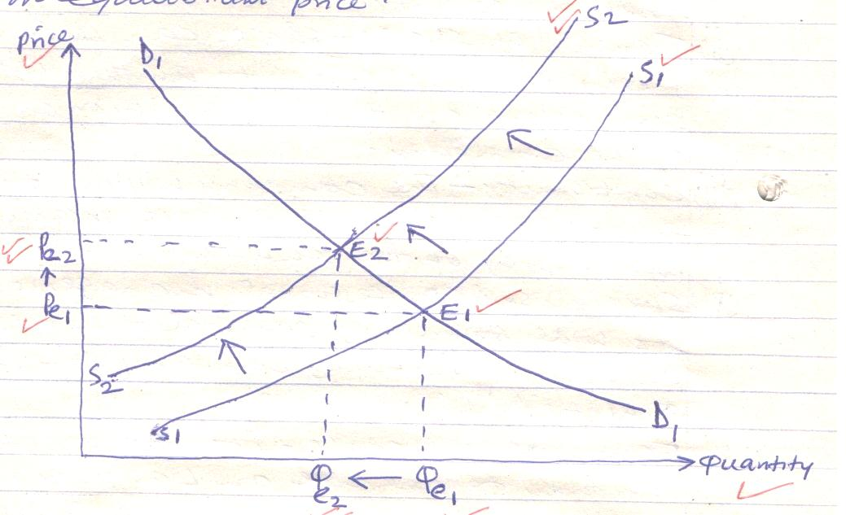
The initial supply curve S₁S₁ and the demand curve is D₁D₁. As a result of decrease in supply, the supply curve shifted to the left from S₁S₁ to S₂S₂. As a result the equilibrium quantity decreased from Qe1 to Qe2 while the equilibrium price increased from Pe₁ to Pe₂. The equilibrium point moved from E₁ to E₂
20 Ticksx¹/₂=10 marks

a) Sources of monopoly power
- Government intervention that favours only one firm/Government creating a monopoly in an area of interest.
- Sole control of a certain raw materials hence deny other firms access to them
- Acquisitions of patent rights from the government/other firms are excluded from production/supply of the product.
- Internal economies of scale that makes the firm to lower its cost of production thus putting off other firms.
- High capital required such that its only one firm can afford to raise such capital
- Possession of a certain technology/knowhow on production of a certain product where other firms do not have
- Where other firms incur extra expenses such as transport costs in order to sell in the market. The existing firm remains the only supplier in the market.
- Where several firms form cartels and operate as only firm
5pointsx2=10 marks
b) Five methods and legislations which the Kenyan government has put in place to protect consumers
- Weights and measures act- The government ensures that all equipment used for measuring products are accurate.
- Food and drugs act- Government ensures that traders do not add harmful ingredients in the processing of their products
- Sale of goods act/trade description act – This legislation ensures that traders do not give wrong description of their products regarding usage or quality.
- Public health act – This legislation ensures that hygienic conditions are followed in the production of goods and provision of services.
- Rent and tribunal act- This legislation ensures that landlords do not exploit their tenants by charging them unreasonable rates.
- Licensing- Through issuance of licenses, the government is able to know the type and nature of business activities carried out by traders (protect consumers from harmful and illegal products).
- Price control- Refers to a situation where the government set a price on certain product especially essential products, within which no trader can exceed.
- Setting standards- The government through KEBS ensures that quality standards are adhered to by producers and sellers.
- Consumer safety act – Ensures and prohibits traders from selling harmful products to consumers
5pointsx2=10marks

