GRADE 1 LESSON NOTES HYGIENE AND NUTRITION
HEALTHY PRACTICES
Healthy habits
These are thing we do to remain and stay healthy
They include:
- Playing
- Washing hands
- Brushing teethes
- Eating healthy food
We practice healthy habits in our life to prevent us from getting diseases.
Healthy habits that prevent us from getting illness
Illness is a disease and we can prevent it by practicing healthy habits
Ways of preventing illness
- Washing hands
- Using toilets and latrines well
- Bathing everyday
- Doing exercises
- Eating healthy foods

Why do we practice healthy habits?
We practice healthy habits to prevent us from contacting diseases e.g washing our hand to removed germs.
We us toilets to prevent us from getting some diseases like cholera
We drink clean water to prevent us from getting typhoid
We do exercise to make our body physically fit.
Doing healthy habits practices,
Learners should go out and do healthy habit like running, skipping and playing football etc.
Exercise
Say if the following foods are healthy or not healthy
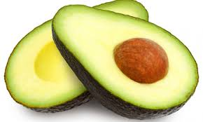
______________________________

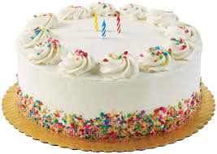
____________________________
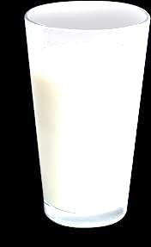
____________________________

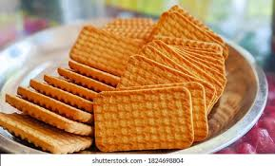
____________________

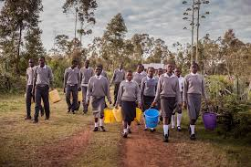
Match the activities with the picture
- Swimming

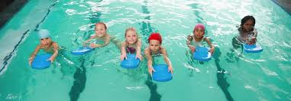
- Riding bicycle

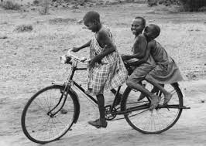
- Playing football

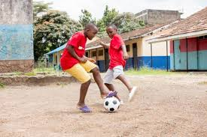
- Walking

Cares for the teeth
When we are born, we grow first set of teeth
This teethes are called milk teeth.
As children grow older they lose this set of teethes and grow new set of teeth called permanent teeth
Removing teeth in a clean way
How to remove teeth in a clean way
- Wash your hands
- Hold the tooth with the clean cloth
- Remove the tooth
- Put the cloth in a bin
- Gurgle salty water
- Gurgle is to take water into the mouth, move it round then spit it.
Exercise
- We wash our ……………………………… before removing teethes (hand, mouth)
- All children grow milk teeth …………………..(true, not true)
- We do not need to go to hospital to remove milk teeth (true, false)

USE OF MEDICINES
Which medicines do we use at home?
Examples of drugs we take at home are:
- Capsules
- Tablets
- Ointment cream
- Using inhaler
- Putting nose drops
- Syrup
Sick people take medicine to feel better
Cares to observe when taking medicine
- Wash your hands when taking the medicines
- Use clean water to take the medicine
- Make sure that you finish the medicine
- Do not share the medicine with anyone
- Store the medicine in a dry place
- Store the medicine away from the baby
Exercises 1.3
- __________ is a type of medicine: (tablet, chair)
- We should always keep medicine in________ (closed, open)
- Touching medicine with dirty hands is (good, bad)
- We should take medicine using clean water?

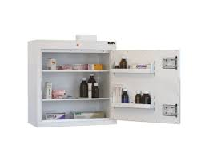

Drug cupboard

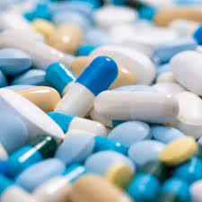
- Tablet drugs

TOPIC: PERSONAL HYGIENCE
Care for the part of the body
Parts of the body

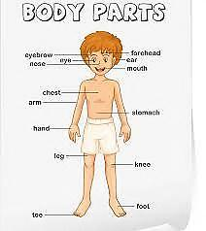

Things we use to clean the body:
- Towel
- Sponge
- Toothpaste
- Handkerchief
- Pumice stone
Pumice stone – is a soft stone for scrubbing the feet.
Handkerchief – is a small cloth used to clean the nose?

How to clean our face
- Put water in a basin
- Close your eyes
- Put soap and rub
- Rinse your face
- Dry with a towel
- Dry with a towel

Cleaning the teeth
- Wet your brush
- Put toothpaste
- Brush your teeth up and down, front and back

We clean our teeth using Colgate, tooth brush/chewed stick, tooth paste, and clean water.
Clean your teeth as least two times a day
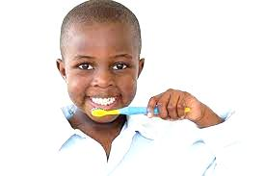

Washing our hands
- Wet your hands
- Put some soap
- Rub in between and all around
- Rinse your hands
- Dry with a towel
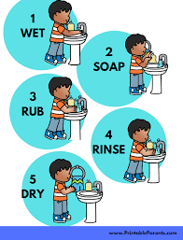

We wash our hands after visiting the toilet and before eating.
Washing our feet
How to clean feet:
- wet your feet
- put some soap
- scrub your feet
- rinse the feet
- dry them with a towel

Always keep your feet clean and dry keep your nails short
Cleaning our hair, nose and ears
- we clean our ears with a soft wet cloth
- we use ear bud to remove wax from the ear
- we use handkerchief to clean our nose
- we use soap and wash our hair then we brush it with a hairbrush or comb to make it neat
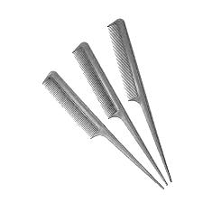
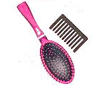
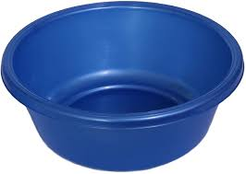

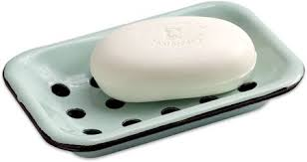

Washing the hair
- put water in a basin
- wet the air
- put some soap
- rub then rinse
- dry and comp
Learners do an extended activity of washing the doll.

Exercise
An all the questions
- we use __________ and ________ to clean our hair
- we use soap, water and _________to wash our hair
- draw two things we use to clean our teeths

- name the parts of the body that we clean using the following pictured items
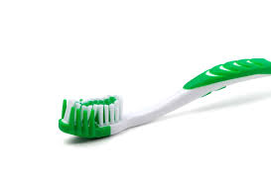

___________

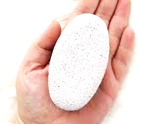

_____________

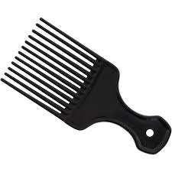
____________

Use of toilets ant latrines
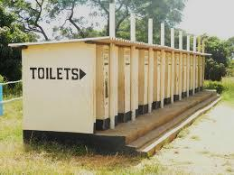

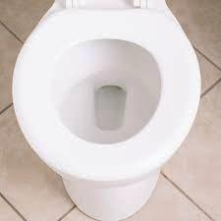
Learners to name things in each of the following pictures
Ask them the ones found in their homes and school
Discuss with them the importance of making toiles and latrines clean
Each pupil to make a sketch of the type available at their home

Note: The latrines are found outside the house
Toilets are found inside the house
Good use of latrines prevent us from contacting illness
We are advice not to go to bush, it is a bad habit
Exercise:
Answer the following questions
After using the toilets, we should________________(talk, flush)
Latrine is to outside the house while toilets is to _________(besides, inside)
Use tissue papers should be _______(reuse, disposed)

FOOD
SOURCES OF FOOD
- learners to name food they eat
- learners to name foods available at their locations

- learners to look at many pictures of food
- learners to name the foods in the pictures

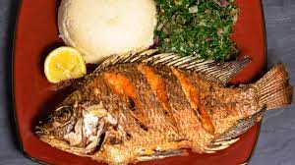
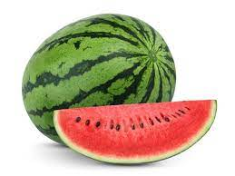
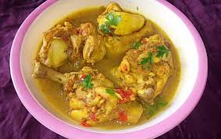

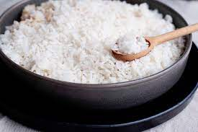

Learners to draw food they eat on the table

ANIMAL AND PLANT FOOD SOURCES
Some foods we eat come from plants e.g
- Cabbage
- Carrots
- Vegetable
Some food we eat comes from animals’ e.g
- Meat
- Eggs
- Milk

Draw and color one food we get from animals and plants

We get bean from _____________ (plants, animals)
Fish, milk and meat are foods we get from (plants, animals)

EATING HABBIT
Foods we eat everyday
Let’s learners name foods they eat everyday
Guide the on the food they eat everyday

Food I like and dislike
- people like some foods
- some foods are not liked by some people
- not all people like foods we like
Draw a table and lets learners copy it on their own book.
In the table learners to write foods they like and dislike

Which foods are good for my teeth?
The foods that are not good for my teeth are
- ice cream
- biscuits
- chocolates
- cakes
- sweets
We should avoid eating too much sugary foods
We should always eat foods that make our teeth strong
The food that makes out teeth strong are:
- milk
- fruits
- sugarcane
Exercise
- foods like ……………………… and ……………………… are not good for our teeths(cakes and biscuits, carots and lemon)
- which foods should we take to make our teeth strong…………………(sugarcane, cakes, carrot)
- Select one food that you like most and is the best for our teeth.

- Draw two foods which are bad for your teeth?
Uses our senses to know food
Food we eat at home and in school
  - guide the learners to name the food they eat at home
  - let’s the pupils name the food they eat at school

Common foods at our locality
Locality is where we come from:
- people comes from different localities and eat difference foods
- some foods are eaten in many homes
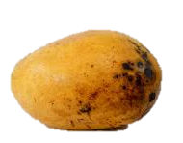
- guide learners to look at the picture and name the foods they eat in the locality

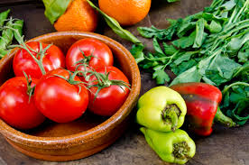
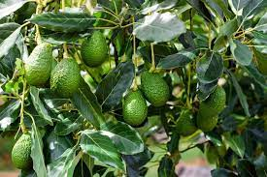
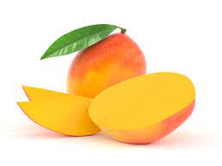
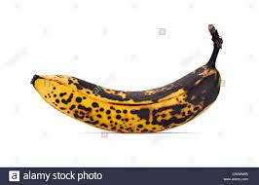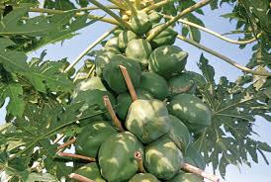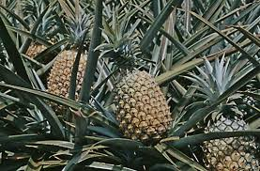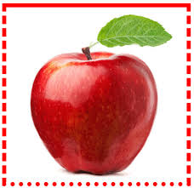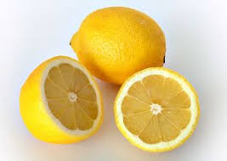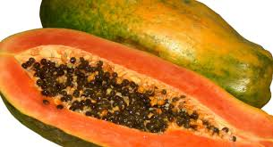

Say the names of the foods in the pictures above
Which of the foods do you eat at home?
Which of these foods do you eat at school?
Name other foods found in your locality?
Senses of food
How do we know food?
How do we know the different kinds of food?
- smelling
- tasting
- touching
- seeing

Learners to bring different kind of foods to school
Leaners in groups cover their eyes one at a time
Guide the leaners to use hands, nose and tongue to tell the type of food

Exercise
Draw and color two foods you eat at home
Foods that taste better are not good for our health, (yes or no)
We can know food by ……………………………….( colour, taste or smell)

Cleaning of fruits
We should clean foods thorouly before eating.

Fruits at our place
- some fruits come from our place
- our place is our locality

Learners to look at the picture and name fruits in their localities
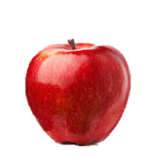
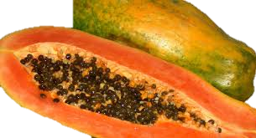
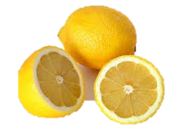
Name the fruits you know in the picture above?
…………………………
………………………..
…………………………
Name and color two fruits found in your locality

Choosing fruits
- all fruits are good for eating
- some fruits are medicine and treat us when we get sick
- We should avoid eating fruits that are bad to our health?

Types of bad fruits are:
- rotten fruits
- dirty fruits
- poisonous fruits

When food goes bad we say it is rotten and it should not be it eaten.
Show learners pictures of different types of fruits
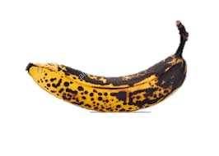
- let the them say whether the food is good or bad for eating

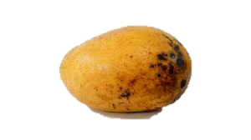

Washing of fruits
- dirty fruits can make us ill
- wash fruits before eating them
- wash fruits with clean and running water

Exercise
We ………………..fruits before eating
Which fruit will you eat A or B?
A
B

Draw two fruits found in your locality
Why we eat
How many times do we need to eat in a day?
- when you wake up in the morning, we eat breakfast
- then in the afternoon we eat lunch
- In the evening before we sleep we at supper.
It is good we eat three meals in a day

Foods we eat at different times
Breakfast
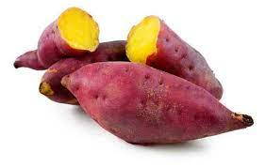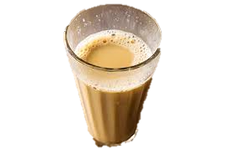

Lunch
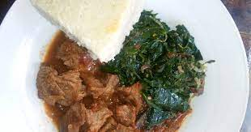

Super’
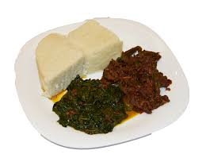

Let the show the food of their choice they eat when they woke up in the morning?
Why do you eat every day?
- we eat every day to get energy
- energy help us play, sing walk , run etc
- we also eat to grow
- we eat to be healthy

Exercise
Name the activities you do at home
Say if you need energy to do them
We eat food to grow and remain healthy
Good behaviors during meal time
Meaning of mealtime
Look at the pictures below

Good behaviors when eating
- Wash your hand before eating
- Serve food that you can finish
- Close your mouth when chewing
- Clear the table after eating

Show the learners the picture and ask them questions
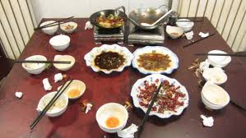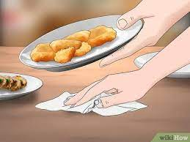
In the above picture which family is showing good behavior in eating?
Why we show behaviors during eating
- bad behaviors manners can cause choking
- serving a lot of food can cause other people to miss food
- showing food in your mouth when eating is a lack of respect
- choking is when food get into the throat

Exercise
Charles Like talking when eating……………… he can get (chocked. Drown)
We only wash our hands after eating………….. (Yes, no)
Do not eat ……………….. food (waste, eat)

BUYING FOOD
Where do we buy food?
We buy food from the following place
- burchery
- kioks
- restaurant
- hotel
- shop
- open air market

kiosk – is a small shop
Restaurant – is a place where cooked food is sold
The food we buy
We buy food from different places
We buy meet from the burchery
We get cooked food from the restaurant
We can buy maize and millet fron an open air market

Lets learners do an exercise of matching pictures on page 67 pupils book grade 1

SAFETY EDUCATION
Common accidents at home
What accidents happens at home

Look at the picture below

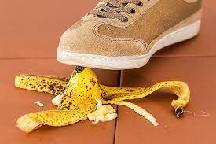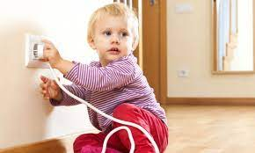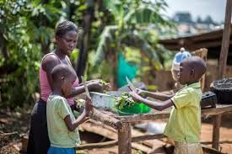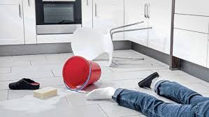

The children in the picture are hurt
They had an accident
An accident is a bad thing that happens to us like cuts, burn and falls
Most accidents we experience at home are cut, burns, falls and chocking

Cuts and burns
Look at the picture below
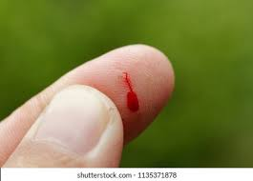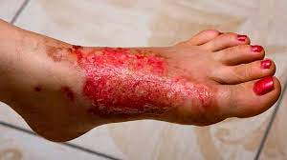

The boy in the picture A has cut his leg and the girl in picture B has a burn
Cuts and burn are common accidents we get at home.
Falls and drowning
Ask learners to look at the picture
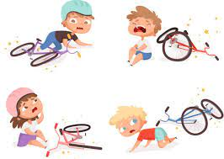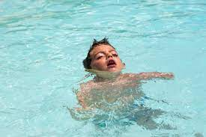
The boy in picture A has shown drowning in water
Falling and drowning are also common accidents at home
Do not cover your heards with bags which can suffocate you
Do not touch or put metals in electric sockets, you can get electric

shock
To suffocate is when you lack air to breathe

Causes of accidents at home
- sharp objects
sharp objects like broken glasses .and knives can cause cut, we should not play with them. Always be carefull when handling them.
Thing that can make us fall are:
- slippery flow
- banana peels
- furniture that are not arranged

Slippery is something which can make you slide

Sockets and flames
Touching sockets is very dangerous, it can cause shock
Playing with fire is also dangerous, it can cause burns

Learners to look at page 75 pupils book grade 1

How can we prevent accidents at home
Wiping water in the floor to prevent fall
Arranging furniture prevent fall
We should put all waste in a dustbin
Always hold a knife with a handle
Do not play with sharp objects such as iron sheets
Do not play near fire
Learners to make posters of preventing different accidents
Exercise
……………………..can cause accidents in the kitchen?
We can prevent fall by ……………………..(keep floor dry playing with knife
Electricity can cause ………………..(electric shock, drowning)

Dangerous chemicals at home
Dangerous is a thing that can harm us
Chemicals like paraffin , soap and insecticides
Which chemical are dangerous at home

Picture of the chemical
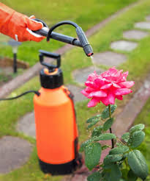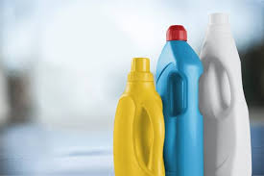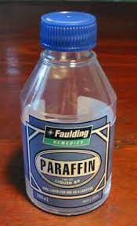
Some chemical can harm us
They are dangerous chemicals

What danger do chemical at home cause
- some soap can damage our skin
- water with sopa can harm our eyes
- we can get ill when we take liquid soap
- parafine also harm our skin
- insecticides can also harm our body
- pesticides are also dangerous

Insecticides are chemicals use to kill insects e.g mosquitoes
Pesticides kill pests e.g weevil

Exercise
Show the dangerous chemical in the diagram below

SIMPLE FIRST AID
WHAT IS FIRST AID
First aid is the first help given to the hurt person
We do firs aid for all accidents
We do first aid to reduce the loss of blood
We do first aid to reduce pain
Learners to look at the first Aid kit on page 89 pupils book grade 1

First Aid kit
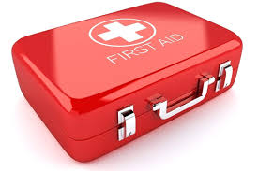
We keep first aid things in a first aid kit
Things found in a first aid kits are”
- bandages
- gloves
- cottonwood
- safety pin
- tweezers
- sterile pad
- Elastoplast
- Scissors

Show learners pictures of items we find in First Aid kit
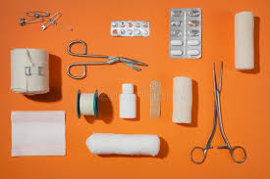
Learners do first aid activities in groups
Lets one pupil in each group act like haved been cotton in the leg
Lets the other do first aid for him/her

Exercise
Your friend has cut herself what will you do?
Name the things below……

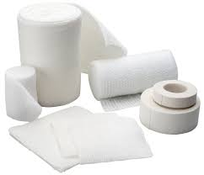

- We do first aid in a cut to stop (pain, crying
- Things used for first Aid are kept in (house, first aid kit
- ………………………are found in first Aid kit (nails. Gloves)

The end

