COMPETENCE BASED CURICULLUM
JUNIOR SCHOOL ASSESSMENT
GRADE 7 2024 TERM ONE
AGRICULTURE 2HOURS
SCHOOL: ……………………………………………………………..……..……
NAME: ……………………………………………..……………………..………..
ASSESSMENT NO: ……………….………. SIGN: ……....DATE: ………..….

ASSESSMENT RUBRICS (for official use)
%SCORE RANGE | Below 40 | 40-59 | 60-79 | 80-100
PERFORMANCE LEVEL | Below expectation | Approaching expectations | Meeting expectations | Exceeding expectations
 | 1 | 2 | 3 | 4

INSTRUCTIONS: Answer all questions in the spaces provided.
Give examples where need be.

Questions
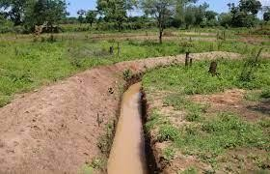
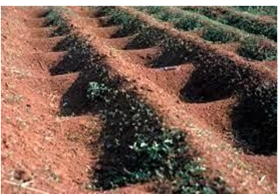
- What are the names of the following water retention structures? (2 mks)

- Define the following term. ( 2mks)
Soil pollution
……………………………………………………………………………………………………………………………………………
- The harmful substances in the soil are known as?
…………………………………………………………….. (1 mk)
- State four Causes of Soil Pollution in Farming. ( 4 mks)
  - …………………………………………………………………..
  - …………………………………………………………………..
  - …………………………………………………………………..
  - ………………………………………………………………….

Soil pollution can be controlled using the following methods: state four methods. (4mks)
  - ………………………………………………………………
  - ………………………………………………………………
  - ………………………………………………………………
  - ………………………………………………………………

State two ways we can use to create awareness message on proper farming practices. (2 mks)
- ………………………………………………
- ………………………………………………

- Create a poster displaying proper ways of farming. ( 4mks)

- Give three farming practices that cause soil pollution in farming. ( 3 mks)
- ………………………………………………………………….
- ………………………………………………………………….
- …………………………………………………………………..

Give four factors to consider when choosing agroforestry trees. (4 mks)
- ……………………………………………………………………..
- ……………………………………………………………………..
- ……………………………………………………………………..

State how to select mother plant trees to provide seeds for establishing agroforestry trees. (3 mks)
- …………………………………………………………………..
- …………………………………………………………………..
- ……………………………………………………………………

Describe three safe farming practices that prevent soil pollution. (3 mks)
  - ……………………………………………………………..
  - ………………………………………………………………
  - ………………………………………………………………

How can we make the members of the community aware of soil pollution control measures? (2 mks)
…………………………………………………………………………………………………………………………………………..

Mention three importance of controlling soil pollution in farming? (3 mks)
- ………………………………………………………………….
- ………………………………………………………………….
- ………………………………………………………………..
- Give three importance of water conservation in farming.(3 mks)
- ……………………………………………………………………
- ………………………………………..…………………………..
- ……………………………………….……………………………
- Match the following methods of planting ( 3mks)
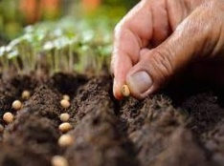
Broadcasting
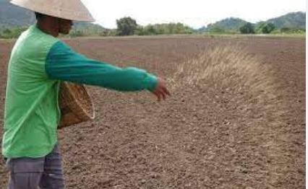
Dibbling
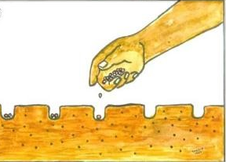
Drilling

What is the term used for describing the water that runs on the ground surface during and after raining? (1mk)
………………………………………..

Name three minimum tillage practices for water conservation carried out in farming. (3 mks)
  - ……………………………… ………………..
  - ……………………………… ………………..
  - …………………………………………………

Give three categories of cuttings. (3mks)
    - ………………………………………….
    - ………………………………………….
    - ………………………………………….

- State two benefits of studying home science for self.(2 mks)

- …………………………………………………………………………….
- …………………………………………………………………………….
- Name three careers and Income generating activities In Home science.(3 mks)
- ………………………………………………………
- ………………………………………………………
- ………………………………………………………
- Write down the meaning of the following terms (4 mks )
Pre-adolescence
………………………………………………………………………………………………………………………………………………………………………………

Food fortification
………………………………………………………………………………………………………………………………………………………………

Blanching
………………………………………………………………………………………………………………………………………………………………

Food enrichment.
………………………………………………………………………………………………………………………………………………………………………………………………
- List any two career opportunities in home science. (2mks)
- ………………………………………….
- ………………..………………………...
- State two ways nutrients are lost when handling food. ( 2 mks)
    - ………………………………..
    - ………………………………..
- Identify the product from the following animal. ( 1mk)
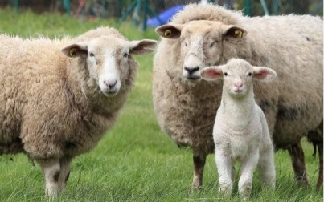

- ………………………………………..
- State two guidelines that helps us to conserve food nutrients during food preparation and cooking.( 2mks)
  - ………………..…………………………………………………..
  - …………………………………………………………………….
- When investigating the effect of different methods of cooking on colour, texture and taste of vegetables, the following safety precautions should be observed namely?( 3 mks)
  - …………………………………………………………………
  - ……………………………………………………………………
  - ……………………………………………………………………

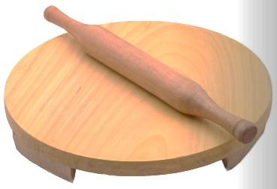
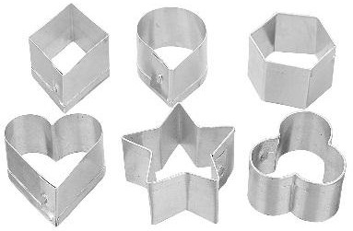
- Name Shaping and molding tools below. (3 mks)


………………………… ……………………… …..……………………

- State two Factors to consider when choosing small kitchen tools and equipment.( 2 mks)

- …………………………………………………………………………
- …………………………………………………………………………

- Identify three Care practices for small kitchen tools and equipment used at home.( 3 mks)

- …………………………………………………………………..
- …………………………………………………………………..
- …………………………………………………………………..

State three Factors determining the choice of a cooking method. (3 mks)
- …………………………………………………………………..
- ……………………………………………………………………
- ……………………………………………………………………

- State the Methods of Cooking different types of foods.( 3 mks)

- ………………………..
- ……………………….
- ……………………….
- State three Equipment used for grilling food.( 3 mks)
- ……………………………………
- ……………………………………
- ……………………………………

- State three guidelines to be followed when grilling different types of foods to ensure the food is well cooked.( 3 mks)
- …………………………………………………………………….
- …………………………………………………………………………….
- …………………………………………………………………………….

- Name Measuring and weighing tools below. ( 3 mks)
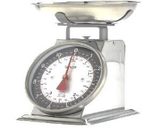

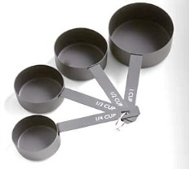
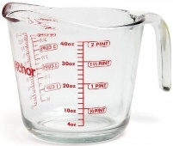

- State two disadvantages of Grilling method of cooking?( 2 mks)
- …………………………………………………………………………..
- ………………………………………………………………………….

- Match the roasting Equipment below to their names. ( 6 mks)

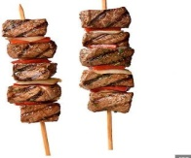
Roasting pan.

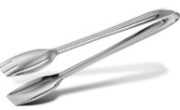
Electric oven

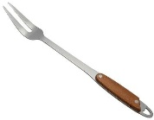
Tongs

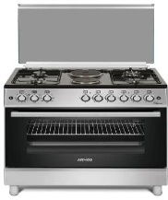

Skewer

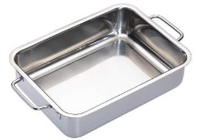
Gas cooker.

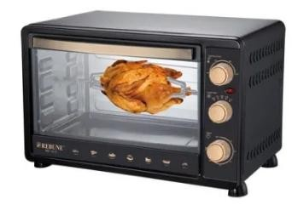

Two prong fork

THIS IS THE LAST PRINTED PAGE
……………….Every learner counts …………

THIS IS THE LAST PRINTED PAGE

