COMPETENCE BASED CURICULLUM
JUNIOR SCHOOL ASSESSMENT
GRADE 7 2024 TERM ONE
INTEGRATED SCIENCES 1hr 30 minutes
FACILITATOR’S NAME: ……………….………………………………………..
TSC NO: ……………………………… sign …………….date ………………….
Confidential: Marking Scheme
RUBRICS (for official use)
Learner’s score
Range | 1-14 | 15-29 | 30-39 | 40-50
Remark | Below expectation | Approaching expectations | Meeting expectations | Exceeding expectations
Please Note: Facilitators are advised to go through the marking scheme as answers given could not be exhaustive.

- What are the three components of integrated science? ( 3 mks)
- Biology

- Chemistry
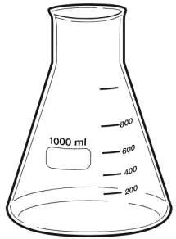
- Physics
- Name the lab apparatus below. (3 mks)
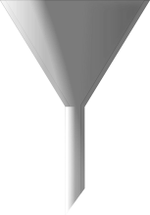
Pipette
Conical flask
Funnel

- Name three careers that are related to the knowledge and skills gained in integrated science.( 3 mks)
- Doctors,
- teachers,
- engineers,
- architects,
- nurses, etc
- Name two common accidents in the laboratory.(2 mks)
- Cuts
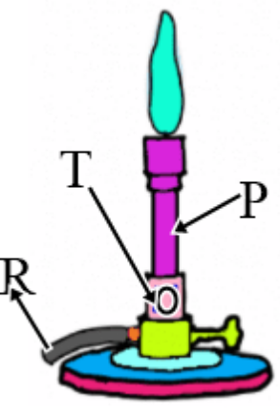
- burns
- Fractures
- scalds
- Name the apparatus below. (1mk)

Bunsen burner

- Name the parts R, T and P. (3mks)
R-gas horse/gas pipe
T-air hole/air inlet
P-chimney
- Give the parts of a light microscope used for. (3mks)
a.) Reflect light on the stage
Mirror
b. Holds the slide that has specimen.
Clips
c. Concentrates light on to the stage.
Diaphragm

Outline two safe ways of handling of the Bunsen burner. (2 mks)
- Always turn off the Bunsen burner after use.
- Always make sure that flammable liquids and combustible materials are not near the Bunsen burner to avoid the risk of unwanted fires and explosions.
- When lighting the gas, have your strikers ready to avoid excess gas leakage that might lead to an explosion.
- Once you are done with the Bunsen burner, it is critical to turn off the main gas valve to avoid leakages.
- The burner should cool completely after use before any further handling.

Outline two uses of bases. (2 mks)
- Manufacturing of soaps and paper involves the use of sodium hydroxide.
- Calcium hydroxide is used to manufacture bleaching powder.
- Magnesium hydroxide is commonly used as a laxative. It also reduces excess acidity in the human stomach and is therefore, used as an antacid.
- Slaked lime can neutralize any excess acidity in soils.

- Identify the following lab hazards.(3 mks)
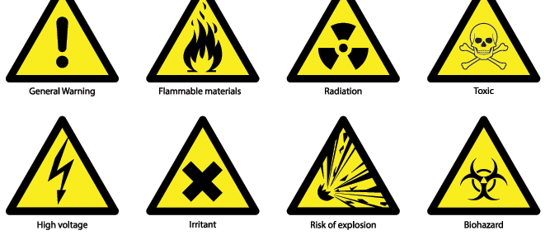

- Indicate their colour in the given solutions. (3 mks)
Indicator | Acidic solution | Neutral solution | Basic solution
Methyl Orange | Red | Yellow | Yellow
Phenolphthalein | Colourless. | Colourless | Pink

State two uses of acids. (2 mks)
- Vinegar has various household uses such as preservation.
- Citric acid is important part of lemon juice and orange juice; it can also be used in food preservation.
- Sulphuric acid is widely used in batteries that are used to start the engines of automobiles.
- Industrial production of dyes, paints and fertilizers involve the use of Sulphuric acids and nitric acid.
- Phosphoric acid is a key ingredient in many soft drinks.

- Identify three basic science skills one gains in science practical.(3 mks)
- Manipulation
- Observation
- Calculation
- Prediction
- Measurement etc
- Name two apparatus used for measuring length.(2 mks)
- Metre rule,
- Rulers,
- Tape measure,
- Vernier calipers

- Give two differences between luminous and non-luminous flame.( 4 mks)
Luminous flame | Non-luminous flame
Yellow/orange in colour | Blue in colours
Used for lighting | Used for heating
Has 4 regions and burns quietly | Has 3 regions and noisy
Produced when air hole is closed | Produced when air hole is open
Produces soot | Does not produce soot
Its wavy and large | Its straight

- Grade 7 students had their practical lesson in the laboratory.name two common accidents their Integrated Science teacher taught them. (2 mks)
- Burns, corrosion
- Falls and fractures
- Fires and explosions
- Cuts and scalds
- Name three protective wear for safety in the laboratory.( 3 mks)
- Gloves
- Overall
- Safety goggles
- Facemask
- Headgear

- The following table represents basic quantities. Write their SI units and their symbols.(5 mks)
 | quantity | SI Unit | Symbol
1 | Length | Metres | M
2 | Mass | Grammes | g
3 | Time | Seconds | s
4 | Electric current | Ampheres | A
5 | Temperature | Kelvin | K
6 | Amount of substance | Mole | mol
7 | Luminous intensity | Candela | Cd

- Name the following parts of the light microscope.( 3 mks)

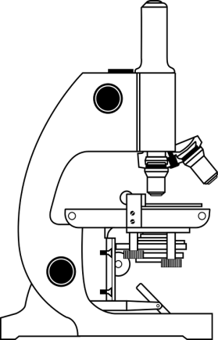
Body tube

Arm

Mirror

THIS IS THE LAST PRINTED PAGE
……………….Every learner counts …………

