COMPETENCE BASED CURICULLUM
JUNIOR SCHOOL ASSESSMENT
GRADE 7 2024 TERM ONE
MATHEMATICS 2 HOURS
Marking scheme
- A milling factory produced 85147000 kg of maize flour in the year 2020.
  - Fill in the number of kilograms produced in the two years in the place value chart below.( 2mks)
Number | HOM | TOM | M | HOT | TOT | T | H | T | O
854147000 | 8 | 5 | 4 | 1 | 4 | 7 | 0 | 0 | 0
- What is the place value of digit 6 after working out the sum of 235,652 and 2,465,021? (1 marks)
Ans Hundreds
- What is the total value of digit 7 after working out the product of 879 and 54? (1 marks)
Ans 7,000
- What is eighty eight million, six hundred and three thousand and eight less a thousand? (1 marks)
Ans 88,602,000
- Round off 587,890 to the nearest hundreds of thousands. (1 mark)
Ans 600,000
- What is the distance round the circular swimming pool below of radius 7m? ( 2mks)

P=πd=22/7×14
Ans =44m
- Find the value of x in the following (2 Mks)
$$15x-60=130+5x$$
Ans X=19

- If r=5, s=2, and t=3, find the value of; (3mks)

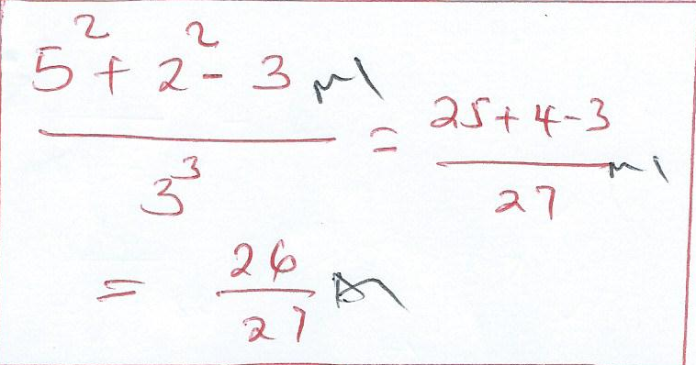
$\frac{r^{2}+s^{2}-t}{t^{3}}$

- Calculate the perimeter of the triangle below.(2 mks)

(x+3) cm (x+3) cm

(2x+1) cm
Ans = (4x+7) cm
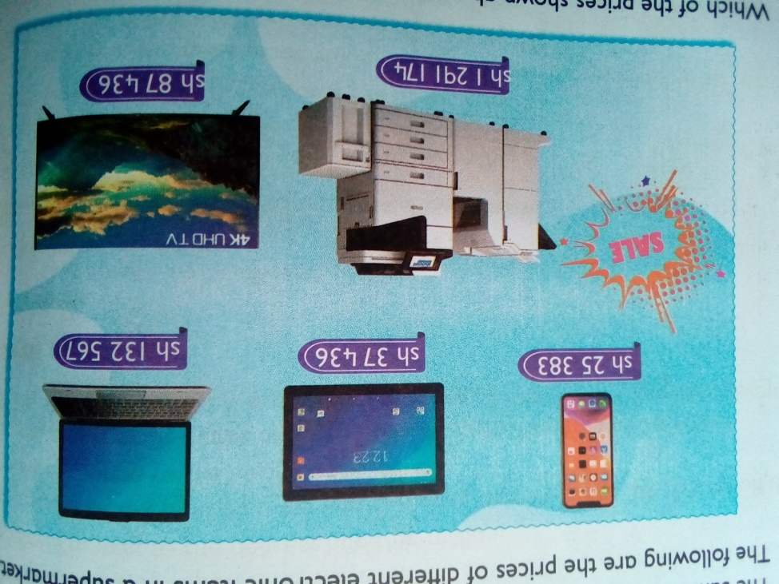
- Olive went to a supermarket to buy digital devices. She saw them displayed as follows:

  - What was the price of a mobile phone? Ans 25,383( 1mk)
  - Of the 5 items, which one was the biggest in size? PRINTER( 1mk)
  - How much more was the printer than the laptop?( 1 mk)
Ans 1,158,607

- Arrange the following numbers in ascending order. ( 1mks)

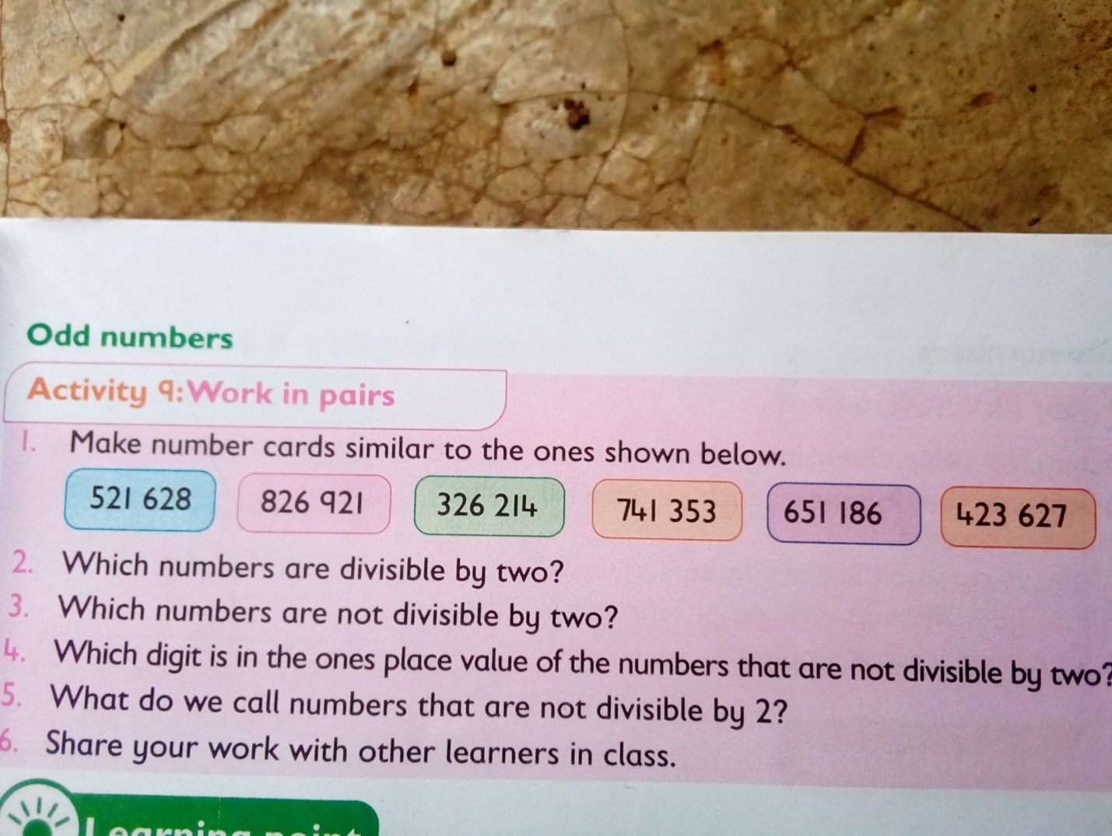

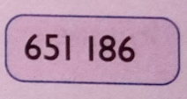

- What is the sum of all prime numbers between 10 and 30? (2 marks)
Ans 110
- Work out the following. (2 marks)
$$63-9×12÷4+28$$
Ans 64

- A certain man won a prize of Kenya shillings sixty million, forty-five thousand, two hundred and ninety. What is this prize written in symbols? (1mk)

Ans 60,045,290

- What is the sum of total values of the digits in the hundreds and ten thousands position in the number 740,536.? (2mk)

Ans 40500

- Work out: (2mk)

45-7x6÷ 12
Ans 41.5

- Ngoya worked out the difference of LCM of 12 and 24 and the G.C.D of 36 and 54. What answer did he get? (2mk)
Ans 6

- The price of a car is sh.4,990,675. How much is the amount rounded off to the nearest thousands? (1mk)
Ans 499,000
- What is the smallest number that can be subtracted from 40658 to make it divisible by 11? (1mk).
Ans
- What is $\frac{2}{3},\frac{5}{6},\frac{3}{4}and\frac{7}{12}$ arranged in increasing order? (1mk)
Ans$\frac{7}{12},\frac{2}{3},\frac{3}{4},\frac{5}{6}$

. The figure below represents the net of a solid. The net is folded to form the solid. How many edges, faces and vertices will the solid have? (3mks)
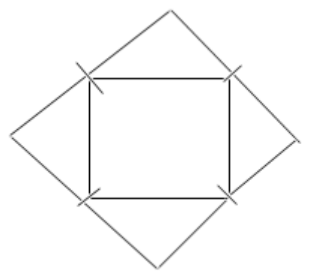
Ans
No of faces=5
No of vertices =5
No of edges=8

- Find the area of the figure below. (2mk)
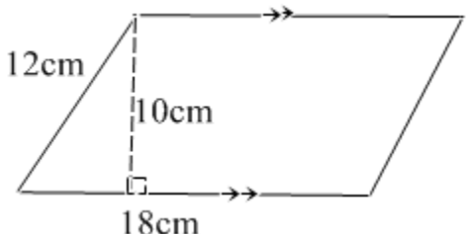 Ans 180CM²
- A school bus left the school at 4.45 p.m to transport learners’ home. What was the time in 24hrs clock system? (1mk)
Ans 1645HRS

- Work out: (2mk)

Tonnes kilograms
15 450
-6 775
Ans 8 675

- A dairy farmer sells 240 000 cm3 of milk every day. How many litres of milk does the farmer sell every day? (2mk)
Ans 240L

- What is the value of x in the equation. (2mks)

5x+3 (x-4)=36
Ans X=6
- Work out. (2mk)
0.072 ÷ 0.6
Ans 0.12
- The area of a rectangular plot is 576m2. What is the length of a square with the same area? (2mk)
Ans 24m
- Work out the following .( 1mk)
  - $33\frac{7}{12}+40\frac{2}{3}$
Ans $74\frac{1}{4}$

THIS IS THE LAST PRINTED PAGE
……………….Every learner counts …………

