COMPETENCE BASED CURICULLUM
JUNIOR SCHOOL ASSESSMENT
GRADE 7 2024 TERM ONE

PRETECHNICAL STUDIES 2hrs 15 minutes
FACILITATOR’S NAME: ……………….………………………………………..
TSC NO: ……………………………… sign …………….date ………………….
Confidential: Marking Scheme
RUBRICS (for official use)
Learner’s score
Remark | Below expectation | Approaching expectations | Meeting expectations | Exceeding expectations
Please Note: Facilitators are advised to go through the marking scheme as answers given could not be exhaustive.
- What is safety?( 2 mks)
Safety is a situation where one avoids causing harm, discomfort or sickness to self and to others when carrying out the daily activities.
- State three examples of safety measures. (3 mks)
- Wearing face mask to prevent spreading of airborne diseases or breathing in dirty air.
- Buckling a safety belt while in a vehicle to avoid falling off the seat in case of emergency brakes.
- Wearing hand gloves when working to avoid injury and dirt to the hands when working.
- Wearing gum boots to protect the feet from injury when working in areas with mud or sharp objects.
- Wearing an overall to guard against soiling clothes.
- What is personal safety? (2 mks)
This is when you take precautions to protect yourself and others while carrying out a task.
- What is a hazard?(2 mks)
A hazard is anything or any action that is likely to cause someone harm, discomfort or sickness in the daily life.

- Name three examples of Hazards to personal safety.( 3 mks)
- Sharp edged tools and objects that can easily cut or poke someone.
- Disarranged rooms where one can easily tumble and fall.
- Naked electric wires that can easily cause electric shock.
- Poorly lit rooms where one can easily know oneself against objects.
- Poorly stored items on the shelves where they can easily fall off and hit someone.
- Working without protective gear where one can easily be hurt or injured.
- Rooms with wet slippery floors where one can easily slip and fall.

- Name two ways used to handle tools and equipment safely while performing tasks in the locality?( 3 mks)
a.) Wearing personal protective equipment like safety goggles, helmet and others.
b.) Picking the right tool for the task at hand.
c.) Avoid throwing or tossing a tool in the direction of or directly to a co-worker.
d.) Never put sharp tools in the pocket.
e.) Keeping safe distance from each other when working with tool. This gives enough space to safely operate without coming into contact with co-workers.
f.) Picking up all hand tools after the job. Idle tools lying around the workplace can lead to tripping.
g.) Unplugging and disconnecting electric power tools when not in use, when making adjustments such as replacing blades and bits or loading fasteners.
h.) Sharpening cutting tools before and after use.

- State two Safety Rules and Regulations at Work.( 2 mks)
- To ensure that you know how to safely perform the task.
- To ensure you know the hazards of the task and how to protect yourself.
- To wear the required personal protective equipment necessary for the task.
- To always work clear of suspended loads.
- To always keep your mind and eyes on the task at hand.
- To obey all warning signs and barricades.
- To inspect all tools and equipment to ensure they are not defective before using them.
- Do not perform a task under unsafe conditions and report any unsafe tools, equipment or hazardous conditions.
- All chemicals containers should be well labelled and covered.
- Maintain good housekeeping at workplace all the time.
- Mention two Careers related to Personal Safety.( 2mks)
- Production of personal safety items such as face masks, hand gloves, ladders, upholstery, fire extinguishers etc.
- Marketing of safety equipment and products as technical sales personnel.
- Personal safety services such as fire officer, coast guards, divers, ambulance drivers, and safety education and training among others.
- Crossing guards
- These are people who help children or adults to cross busy roads
- Safety engineers
- These are people who monitor a working environment and inspects buildings and machines. They later recommend the safety precautions to be observed in the working environment
- Life guards
- These are people who help children and adults to swim safely. There also ensure that all people are following rules set by the swimming place. They attend to those who face challenges while swimming
- Risk manager.
- This person researches and makes a report on the safety of a particular work and the hazards that are expected.
- Environment health and safety consultants.
- They perform some roles similar to those of safety engineers. They offer advice on how to minimise health and safety risks in the workplace.

- What is the Role of safety in day-to-day life?( 2mks)
- Personal safety plays an important role in the day-to-day life because:
- It reduces our exposure to risks of hurting ourselves and others.
- It makes one carry out an activity without fear.
- It makes one focus on the activity he or she is doing.
- It makes one work faster on an activity.
- It makes one feel confident in life.

- Name two common types of injuries that occurs in the locality? (2 mks)
- A burn is an injury caused by a flame.
- A scald is an injury caused by hot liquid or team.
- A cut is a tear or opening in the skin by a sharp object.
- Fracture is a partial or complete break of a bone.
- Sprains
- Pricks
- Bruises

- State two Causes of injuries in the locality?( 2 mks)
- Cuts which are caused by sharp objects or tools and equipment like knives. Also can be caused by sharp furniture corners or rough edges.
- Burns which are caused by fire or hot objects or touching open flames.
- Scalds which are caused by hot liquids or steam.
- A fracture which is caused by twisting of an arm or leg resulting from during falls or slips.

- What is the Reason for first Aid?( 2mks)
- To preserve life.
- To prevent the condition from worsening or to promote recovery.

- State three Items Contained in A First Aid Kit.( 3 mks)
- Bandages.
- Adhesive tape.
- Gauze roll and pads.
- First Aid manual.
- Safety pins.
- Tweezers.
- Scissors.
- Antiseptic wipes.
- Emergency blanket.
- Gloves.
- Thermometer.
- Instant cold pack.
- Elastic bandages.
- Triangular bandages

- Name the following items

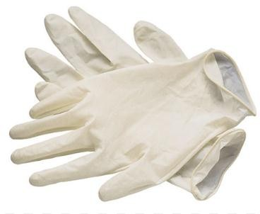
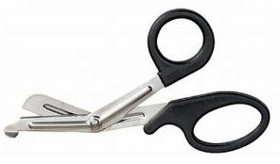
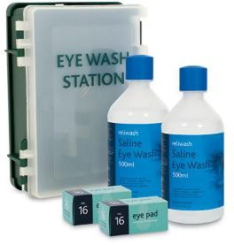
Eyewash. Disposable gloves Scissors

- Describe the Procedure of Administering First Aid for Cuts. ( 6 mks)
- Wash the Injured part. This helps to kill germs around the wound.
- Stop the bleeding. Apply gentle pressure with a clean bandage or cloth and elevate the wound until bleeding stops.
- Clean the wound. Rinse the wound with water or spirit to reduce the risk of infection.
- Apply an antibiotic or petroleum jelly. Apply a thin layer of an antibiotic ointment or petroleum jelly to keep the surface moist and help prevent scarring.
- Cover the wound. Apply a bandage or gauze to keep the wound clean. If the injury is just a minor scrape or scratch, leave it uncovered.
- Get a tetanus injection. Get a tetanus injection shot if you have not had one in the past five years and the wound is deep or dirty.
- Watch for signs of infection. Visit a doctor if you experience signs of infection on the skin or near the wound such as increasing pain or swelling.
- Describe the Procedure of Administering First Aid for Fracture. ( 6 mks)
- A fracture is a broken bone. Call for any assistance in case of the following:
- The broken bone is the result of major trauma or injury.
- The person is not breathing or is not moving.
- There is heavy bleeding.
- Gentle pressure or movement cause pain.
- The limb or joint appears deformed.
- The bone has pierced the skin.
- The extreme end of the injured arm or leg such as a toe or finger is numb.
- You suspect a bone is broken in the neck, head or back.

- Mention three careers Related to first Aid and Management of Injuries. ( 3 mks)
- Production of first aid items such as first aid kits, stretchers, wheel chairs and oxygen cylinders among others.
- Merchandising in first aid equipment and products as technical sales personnel.
- First aid services such as Para-medicine, nursing, and first aid education and training among others.
- Emergency repose nurses
- Paramedics
- Ambulance drivers
- Fire fighters
- Flight attendants
- Professional baby sitters
- Lifeguards
- Games instructors
- Gym instructors
- Mention five common materials found within the locality are( 5 mks)
- Wood.
- Stones.
- Textile.
- Soil.
- Glass.
- Leather.
- Plastics.
- Rubber.
- Water.
- Water.
- Copper.
- Aluminum.
- Steel.
- Silver.
- Air

- Business studies as a learning area composed of various disciplines such as? (5 mks)
- Commerce
- Accounting
- Economics
- Entrepreneurship
- Financial literacy

- Stephaney would like to tell a genuine KSH 500 note from a fake one. Explain to him the features of a genuine KSH 500 note. (3 mks)
- The main colour is green
- The front side features coat of arms, statue of President Jomo Kenyatta, KICC.
- The animal symbol is a lion
- The back side features tourism and wildlife
- Water mark feature are lions head and electrotype 500
- Mention three benefits of learning business studies. (3 mks)
- Assists the learners/members of the society to acquire knowledge and awareness of business terminologies which are necessary when discussing business issues such as profit and loss.
- Assists the individuals in appreciating the role of business in society/in provision of goods and services.
- It enables the learners to acquire basic knowledge, skills and attitudes necessary for the development of self and the nation by starting and operating business.
- Equips the members of society with knowledge and skills necessary to start and run a business comfortably.
- Makes the members of society to appreciate the need for good business management practices
- Assists individual to acquire self-discipline and positive attitude towards work
- Equips individual with abilities to promote co-operation in society through trade
- Enables the individual to understand the role of government in business activities
- Equips individuals with abilities to understand the role of communication and information technology in modern business management
- Helps the individuals to develop positive attitudes towards the environment
- Equips the individual with knowledge and skills required to evaluate business performance
- It helps individual to develop various intellectual abilities such as inquiry, critical thinking, analysis, interpretation, rational judgment, innovation and creativity.
- It enables learners to acquire skills for wise buying and selling.
- It creates a firm foundation for further education and training in business and other related fields.
- It enables one to understand and appreciate the basic economic issues that affect the society such as increase in prices of goods and services.
- Draw the animal symbol found in the following note. (3 mks)
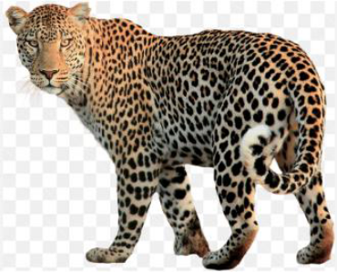
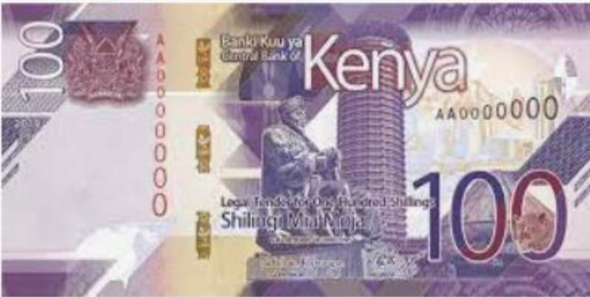
- State one example of a good and one example of a service that can be bought and sold in a business. (4mks)
Goods | Services
Foods | Banking
clothes | Education
Utensils | Transport
Stationeries | communication
Cars | Tourism etc

- Match the following themes and symbols on the Kenyan currency. (5 mks)
Governance
Wind power, geothermal power, and solar power

Social services
Beach, parks, lions

Tourism
Medical services, education, athletics

Green energy
Maize, tea, livestock

Agriculture
National assembly
- Who is a customer? (2 mks)
A customer is someone willing to buy a good or a service
- What is the Meaning of a business? (2 mks)
This refers to any activity carried out by an individual or by an organization with the aim of making a profit.

- Define
Profit (2 mks)
It is what the business earns above what it spends in providing goods and services to the people who need them.
- What are the Reasons for the existence of businesses? State four points. (4 mks)
- To provide goods and services-Businesses exist to satisfy the needs and wants of buyers by providing them with goods and services. Buyers include individual consumers, other businesses and the government.
- To create employment-Businesses provide job opportunities through which members of society can earn money, which can be used to buy goods and services for the satisfaction of their needs.
- To earn profit-Profit is the primary goal of carrying out business operations. It is earned by the people who put their resources and effort in business
- As an outlet of new innovation-Some businesses provide unique goods and services which may not be existing in society e.g. plastic fencing poles that are now replacing wooden poles.
- To be as own boss-Some people run businesses so as to be in full control of the operations and make all the decisions regarding the business without need of reference to people.
- To utilize extra resources-Some people go into business to make use of money or property which is not being put to profitably use at a given time.
- To offer special services-Some businesses provide services that raise the living standard of people e.g. government enterprises that provide public utilities such as health care and water.
- To utilize spare time-Some people run businesses in order to make use of extra time at their disposal and in the process make some extra money. A large number of formally employed people have small business which they run during their free time in order to earn more money.
- State five business activities that are involved in the selling and buying of goods and services in your locality. (5 mks)
- Managing a carwash center
- Running a hotel/shop businesses
- Shoe shining business
- Water vending business
- Fruit vending
- Food sellers
- Running a salon, cyber café, boutique of a kinyozi
- State any five Business activities. ( 5 mks)

- Extraction
This involves obtaining goods from their natural setting e.g. mining, farming, lumbering, fishing, quarrying etc.

- Processing-This involves the conversion of raw materials into more useful products without combining it with other goods. Examples here include milling/grinding flour, refining oil, tanning of skins and hides, conversion of iron into steel etc.

- Manufacturing-This involves combining different raw materials to come up with one final product. Such activities include bread baking, making a table etc.
- Construction-This involves building of structures such as bridges, ships, aero planes, houses, roads, railways etc.
- Distribution of goods-This refers to the activities involved in moving goods from where they are produced to where they are needed. People who carry out distribution are called distributors. Examples of distributors are wholesalers and retailers.
- Trade-Activities in this category involve the buying and selling of goods with a view of making a profit. People involved in trade are called traders.
- Provisions of services-Activities in this category involve human acts which could be mental or physical. These include activities such as hair-cutting, hair styling, car-washing, nursing, teaching, driving, and entertaining etc.

- Explain the meaning of the word money.(2 mks)
It is anything that is generally accepted as means of payment for goods and services in a given country.
- Write down five uses of money (5 mks)
- It serves as a medium of exchange.
- It serves as a measure of value.
- Transfer of immovable property.
- It serves as a store of value.
- It is used to settle debts in future.
- It serves as a unit of account.

Identify the following parts of a computer. (5 mks)
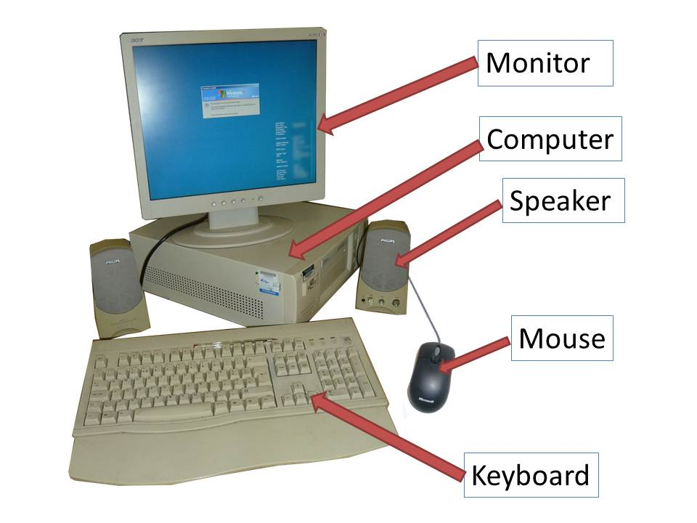

Identify three advantages of using computers in banks (3 mks)

Speed and accuracy

Easy to access information

Easy to update records

Requires less space for storage

Improves data security and privacy

Define the term ‘computer laboratory’ (2 mks)

- A computer laboratory is a room that has been specially prepared to facilitate installation of computers, and provide a safe conducive environment for teaching & learning of Computer studies.

Give two factors to be considered when preparing a computer laboratory (2 mks)

Security of computers

Reliability of the source of power

Number of computers to be installed and the amount of space available

The maximum number of users that the laboratory can accommodate

Explain why smoke and Dust particles are harmful to a computer. (2mks)

Dust and smoke particles settle on storage devices and may scratch them during read/ write operation

It affects the cooling of the computer

List down three safety precautions one should observe when entering a computer laboratory (3 mks)

Avoid smoking or exposing computers to dust

Avoid carrying foods & drinks/ beverages to the computer room

Avoid unnecessary movements as you may accidentally knock the peripheral devices

Only authorized people should enter the computer room

Computers users should be trained on how to use computers frequently

Computer illiterates should not be allowed to operate the computers

Collect any waste papers which might be lying in the computer room & put them into the dustbin

Shut the door of the computer room properly

Describe the ideal environment for a computer to work properly (3 mks)

Should be free from dust, water and magnets

Should be kept in well ventilated rooms with optimum (medium) humidity
- List any four types of personal data. (4mk)
- include information on name,
- address,
- e-mail address,
- personal identification number,
- registration number,
- photo,
- fingerprints,
- diagnostics,
- biological material,
- List the components of the CPU. (3mks)
- arithmetic and logic unit (ALU),
- a control unit,
- Various registers.
- List any computer hardware components. (1mk)
Computer hardware includes the physical parts of a computer, such as
- The case,
- Central processing unit (CPU),
- Random access memory (RAM),
- Monitor,
- Mouse,
- Keyboard,
- Computer data storage,
- Graphics card,
- Sound card,
- Speakers and
- Motherboard.

- Write four factors to consider when selecting appropriate hardware components. (4mk)
- User Experience. The “user experience” is about the feeling a person gets when making use of a hardware device. ...
- User Needs. This is about what the user wants to use the hardware for. ...
- Compatibility. ...
- Cost. ...
- Efficiency. ...
- Implementation. ...
- Productivity. ...
- Security.

- Write in full. (4mks)

a.) ALU
The full form of ALU is arithmetic logic unit. It is a combinational digital circuit that performs arithmetic operations on binary numbers.
b.) USB
USB, in full universal serial bus, technology used to connect computers with peripheral devices
c.) HDMI
The full form of HDMI is the High Definition Multimedia Interface. It is an all-digital audio-video interface that transmits information to a computer monitor, video projector, and digital television and so on, in uncompressed mode.
d.) CPU-Central Processing Unit

- Explain one problem experienced when setting up computers. (1mk)
- The Computer Won't Start. A computer that suddenly shuts off or has difficulty starting up could have a failing power supply.
- The Screen is Blank.
- Abnormally Functioning Operating System or Software.
- Windows Won't Boot.
- The Screen is frozen.
- Computer is Slow.
- Strange Noises. .
- Slow Internet.

- State one functions of a computer. (1mk)
The functionality of any computer mainly includes the following tasks;
- Taking input data,
- Processing the data,
- Returning the results,

- Give the names of the following cables used with computes. (3mks)
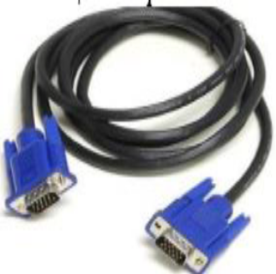
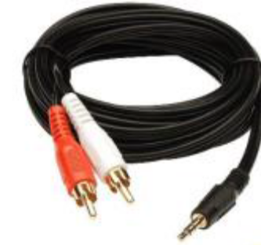
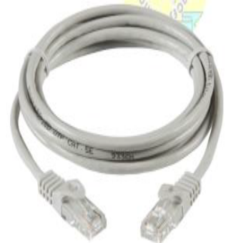
A B C

- ETHERNET cable
- VGA cable
- AUX cable

- State physical threats to computers. (1mk)
- Virus.
- Trojans.
- Worms.
- Spyware.
- Key loggers.
- Adware.
- Denial of Service Attacks.
- Distributed Denial of Service Attacks.
THIS IS THE LAST PRINTED PAGE
……………….Every learner counts …………

