COMPETENCE BASED CURICULLUM
JUNIOR SCHOOL ASSESSMENT
GRADE 7 2024 TERM ONE

PRETECHNICAL STUDIES 2hrs 30mins minutes
SCHOOL: ……………………………………………………………………………..……
NAME: ……………………………………………………..……………………..………..
ASSESSMENT NO: ……………….………. SIGN: …....DATE: ………..….
ASSESSMENT RUBRICS (for official use)
%SCORE RANGE | Below 40 | 40-59 | 60-79 | 80-100
PERFORMANCE LEVEL | Below expectation | Approaching expectations | Meeting expectations | Exceeding expectations
 | 1 | 2 | 3 | 4

FOR EXAMINERS
Out of | 100 Marks
Learner’s score
Percentage score (%)
PERFORMANCE LEVEL

INSTRUCTIONS: Answer all questions in the spaces provided.

- What is safety?( 2 mks)
………………………………………………………………………………………………………………………………………………………………………………
- State three examples of safety measures. (3 mks)
- ……………………………………………………………………………………….
- ……………………………………………………………………………………….
- ………………………………………………………………………………………
- What is personal safety? (2 mks)
………………………………………………………………………………………………………………………………………………………………………………
- What is a hazard?(2 mks)
……………………………………………………………………………………………………………………………………………………………………………….

- Name three examples of Hazards to personal safety.( 3 mks)
- ………………………………………………………………………….
- ………………………………………………………………………….
- ………………………………………………………………………….

- Name three ways used to handle tools and equipment safely while performing tasks in the locality?( 3 mks)
- …………………………………………………………………………………….
- ……………………………………………………………………………………
- …………………………………………………………………………………..

- State two Safety Rules and Regulations at Work.( 2 mks)
- ………………………………………………………………………..
- ……………………………………………………………………….
- Mention two Careers related to Personal Safety.( 2mks)
- …………………………………………………………………………………
- ………………………………………………………………………………..

- What is the Role of safety in day-to-day life?( 2mks)
- …………………………………………………………………………………
- …………………………………………………………………………………
- Name two common types of injuries that occur in the locality? (2 mks)
- …………………………………………………………….………………………….……
- ……………………………………………………………………………………………..

- State two Causes of injuries in the locality?( 2 mks)
- ………………………………………………………………………………….
- …………………………………………………………………………………

- What is the Reason for first Aid?( 2mks)
…………………………………………………………………………………………………………………………………………………………………………………………………………

- State three Items Contained in A First Aid Kit.( 3 mks)
  - ………………………………………………
  - ……………………………………………….
  - ……………………………………………….

- Name the following items

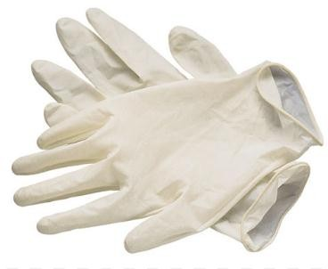

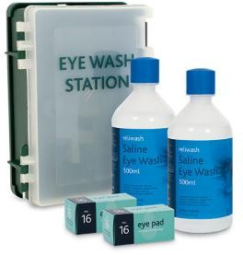
……………….…… ………….…………… …………….……………..

- Describe the Procedure of Administering First Aid for Cuts. ( 6 mks)
- ……………………………………….………………………..……………….
- …………………………………………….…………………………………….
- …………………………………………………….………….…………………
- ………………………………………………………………………………….
- ……………………………………………………………..……………………
- ……………………………………………………………..……………………

- Describe the Procedure of Administering First Aid for Fracture. ( 6 mks)
- ……………………………………………………………………………………….
- ……………………………………………………………………………………….
- ……………………………………………………………………………………….
- ………………………………………………………………………………………..
- ……………………………………………………………………………………….
- ……………………………………………………………………………………….

- Mention three careers Related to first Aid and Management of Injuries. ( 3 mks)
- …………………………………….
- …………………………………….
- ………………………………………

- Mention five common materials found within the locality are( 5 mks)
- ……………………………….
- ………………………………
- ……………………………….
- ……………………………….
- ………………………………

- Business studies as a learning area composed of various disciplines such as? (5 mks)
- ………………………………………
- ……………………………………….
- ……………………………………….
- ……………………………………….
- ……………………………………….

- Stephaney would like to tell a genuine KSH 500 note from a fake one. Explain to her the features of a genuine KSH 500 note. (3 mks)
- ……………………………………………………………………
- ……………………………………………………………………
- ……………………………………………………………………
- Mention three benefits of learning business studies. (3 mks)
- ………………………………………………………………………
- ………………………………………………………………………
- ………………………………………………………………………
- Draw the animal symbol found in the following note. (3 mks)
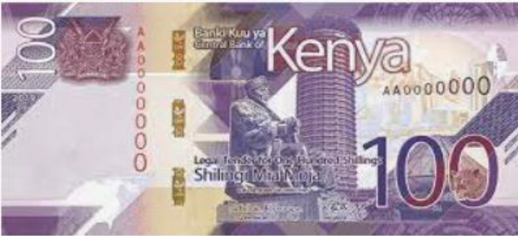

- State one example of a good and one example of a service that can be bought and sold in a business. (4 mks)
Goods | Services

- Match the following themes and symbols on the Kenyan currency. (5 mks)
Governance
Wind power, geothermal power, and solar power

Social services
Green energy
Beach, parks, lions
Maize, tea, livestock
National assembly
Medical services, education, athletics
Agriculture
Tourism

- Who is a customer? (2 mks)
……………………………………………………………………………………………………………………………………………
- What is the Meaning of a business? (2 mks)
…………………………………………………………………………………………………………………………………………………………

- Define :Profit (2 mks)
……………………………………………………………………………………………………………………………………………………
- What are the Reasons for the existence of businesses? State four points. (4 mks)
- …………………………………………………………………
- …………………………………………………………………
- …………………………………………………………………
- …………………………………………………………………
- State five business activities that are involved in the selling and buying of goods and services in your locality. (5 mks)
- ………………………………………………………..
- ………………………………………………………..
- ……………………………………………………….
- ………………………………………………………..
- ……………………………………………………….
- State any five Business activities. ( 5 mks)

- ……………………………………….
- ……………………………………….
- ……………………………………….
- ……………………………………….
- …………………………………………
- Explain the meaning of the word money.(1 mk)
……………………………………………………………………………………………………………………………………………………
- Write down two uses of money (2 mks)
- ………………………………………………………………..
- ……………………………………………………………….
- ……………………………………………………………….
- ……………………………………………………………….
- ………………………………………………………………..

Identify the following parts of a computer. (5 mks)
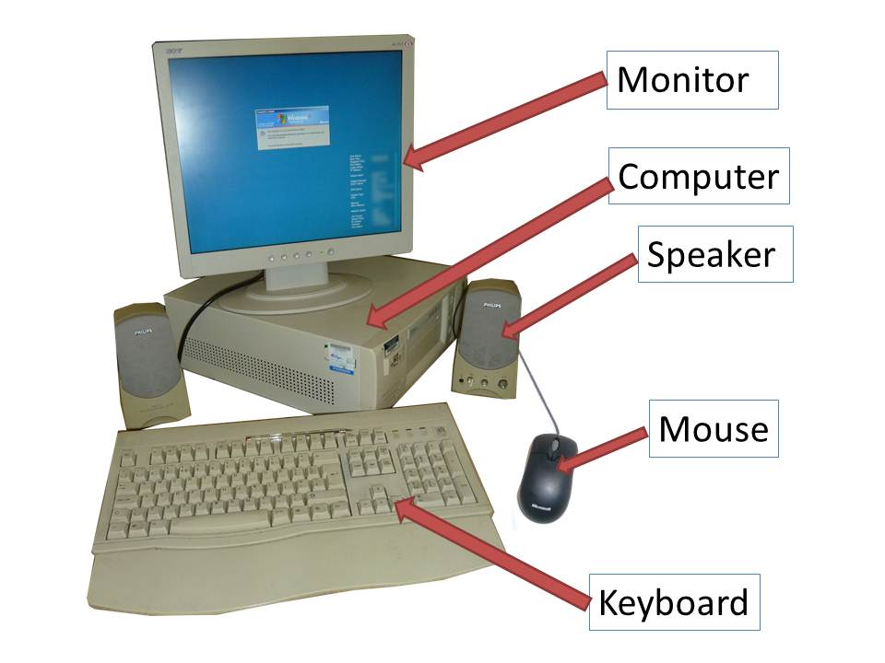

Identify three advantages of using computers in banks (3 mks)

……………………………………………………….………………………

………………………………………………………………………..………

………………………………………………………………………….……

Define the term ‘computer laboratory’ (2 mks)

……………………………………………………………………………………………………………………………………………………………………………………………………………………………………………………………………..

Give two factors to be considered when preparing a computer laboratory (2 mks)

………………………………………………………………….………

………………………………………………………………..…………

…………………………………………………………………….……

Explain why smoke and Dust particles are harmful to a computer. (2mks)

…………………………………………………………………….………

…………………………………………………………………….………

List down three safety precautions one should observe when entering a computer laboratory (3 mks)

……………………………………………………………………………

……………………………………………………………………………

…………………………………………………………………………..

Describe the ideal environment for a computer to work properly (3 mks)

……………………………………………………………………….………

…………………………………………………………………….…………

……………………………………………….…………………….……….
- List any four types of personal data. (4mk)
- ……………………………………………
- ……………………………………………
- ……………………………………………
- …………………………………………..
- List the components of the CPU. (3mks)
- ……………………………………………………………………………..
- ……………………………………………………………………………..
- ……………………………………………………………………………..
- List any two computer hardware components. (2mks)
- …………………………………………………………………………………..
- ………………………………………………………………………………….
- ………………………………………………………………………………….

- Write in full. (2mks)

a.) ALU …………………………………………………………………………….
b.) USB ……………………………………………………………………………...
c.) HDMI ……………………………………………………………………………
d.) CPU……………………………………………………………………………...

- Explain one problems experienced when setting up computers. (1mk)
- ………………………………………………………………………………

- State one functions of a computer. (1mk)
- ……………………………………………………………………………..

- Give the names of the following cables used with computes. (3mks)
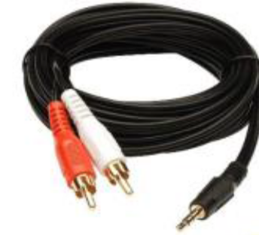
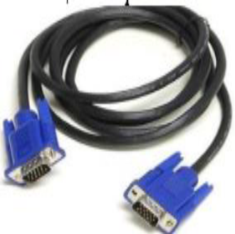
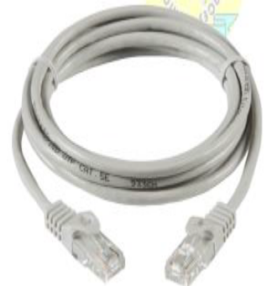
A B C

- ……………………………………….
- ………………………………………..
- ……………………………………….

- State one physical threats to computers. (1mk)
- ………………………………………………………………………….
THIS IS THE LAST PRINTED PAGE
……………….Every learner counts …………

